SEBRING INTERNATIONAL

TMX MXR BUILD MANUAL

This build manual details the construction procedure for all UK manufactured SEBRING INTERNATIONAL TMX MXR models. As a component based vehicle the builder may wish to change some or many details of the vehicle to personalise the end result and a full record of these alterations, if included in the back of the build manual, will enhance the subsequent resale value of the car and provide an invaluable source of reference should future repairs be required. A number of blank pages are included at the end of this manual for this very purpose and we suggest they are fully utilised in the event of changes.

Also supplied is a complete list of all the mechanical fasteners used and their locations on the vehicle which will ensure you use the correct fasteners for the job at hand and can be used for reference during assembly.

All reference to left and right of the vehicle are presumed from the driver’s seat facing forwards (left being nearside, right offside) and all measurements are imperial unless stated otherwise in the relevant text or diagram.

The order in which this manual is presented is intended to be the order of construction and should be adhered to if possible as many facets of the build are inter-related and bypassing the order of things can cause unnecessary effort at a later stage in removing items for access.

In order to enjoy the experience of constructing your own unique vehicle a well lit working area approximately twice the size of the finished vehicle will be a great advantage as it allows the rolling chassis stage to be completed whilst the body sections are stored alongside, a sturdy workbench with a good sized vice attached will simplify a great many tasks, as will a varied selection of hand tools. A few special tools will be required during the course of the build, i.e. coil spring compressors and a clutch aligning tool, all of which are available from tool hire shops or the relevant job can be completed by SEBRING INTERNATIONAL on request.

- Page 1 -
GENERAL RECOMMENDATIONS & PRECAUTIONS

ALWAYS observe common sense safety recommendations as various items and substances included in the vehicle can cause injury if misused, there are also a good number of heavy items in a vehicle’s construction so ensure you take great care when lifting axles or engine and gearbox assemblies to avoid personal injury.

Study this manual carefully before you start work and ensure that all tools and materials needed to complete the task are arranged.

Protective clothing is essential when sanding, drilling or cutting fibreglass and metal. A sturdy pair of gloves and a good quality facemask should be considered an essential investment.

Be very wary of compressed springs and keep your body at the side of the spring unit not above it.

Cut fibreglass edges are very sharp and long spikes are sometimes present, always wear gloves and advise helpers to do likewise when lifting body sections around.

When drilling holes larger than 1/4” in steel use a 1/8” pilot drill first. When drilling fibreglass use a countersink to make a hole slightly larger than the finish sized hole then drill the hole through the centre to avoid chipping the gel-coat finish.

When assembling the body panels cover the outer face with a soft material held with masking tape to avoid damage to the gel-coat finish.

Read the instructions carefully on all adhesives and solvent based cleaners carefully before use.

Petrol is an explosive liquid so treat with respect and clear any spills up immediately, keep all naked flames and sparks well away from fuel tanks and lines, KEEP A FIRE EXTINGUISHER HANDY AND KNOW HOW TO USE IT.

DO NOT SMOKE while working with fuel or solvent based glue.

- Page 2 -
GENERAL RECOMMENDATIONS & PRECAUTIONS – Continued…

Use the correct tools for the job and keep them clean, beware of back injury and use jacks or lifting equipment where necessary.

Invest in good quality axle stands to support the car, and keep all jacks in good condition.

Only connect the battery when needed to test electrical systems until the car is finished.

Always use the new brake pipes and service all braking components according to manufacturer’s specification if using re-conditioned parts.

Fill all systems with approved and recommended fluids only.

Before the maiden voyage check all controls, gauges and components for correct function and security, if possible get another person to aid you in this check as they can be more objective when looking for that loose nut or bolt.

- Page 3 -
ASSEMBLE THE FRONT SUSPENSION

Study the upper and lower wishbone assemblies shown in Drawing No. TMX001 and TMX002.

Starting with the lower wishbones; using a vice, press in the polyurethane halves. Once these have been fitted the inner sleeves can be pressed in – they will need to be coated in COPASLIP grease before pressing in. Also try to fill the gap between the urethane halves with COPASLIP. Ensure that you have the correct sleeves as the front lower wishbones are a different length to all the others.

The lower wishbones can now be bolted to the chassis using the bolts and castor shims supplied in the bolt kit - the correct location of the castor shim is shown in Drawing No. TMX001.
Ensure that you fit the wishbones to the correct side of the chassis and once you have done this you can bolt the lower ball joints into place.

Press the urethane halves and 5/8” inner sleeves into the rod ends, coat the rod ends threads with COPASLIP and fit the lock nuts. Screw the rod end assemblies into the top wishbones leaving approx. 12mm of thread exposed. The upper wishbones can now be bolted to the chassis using the bolts and castor shims supplied in the bolt kit - the correct location of the castor shim is shown in Drawing No. TMX002

The front shock absorbers can now be fitted. Fit the top of the shock to the chassis with the bolts and spacers (one either side of the shock bush) provided with the kit.

The shock absorber then passes through the lower wishbone and is then bolted to the underside of the wishbone with the bolts and lower spacer supplied with the kit. The spacer should be fitted to the front of the car and the shock should be positioned so that the damping adjuster also faces the front of the car. The top ball joints can now be bolted to the wishbones.

- Page 4 -
DRAWING No. TMX001
Front lower wishbone – nearside shown
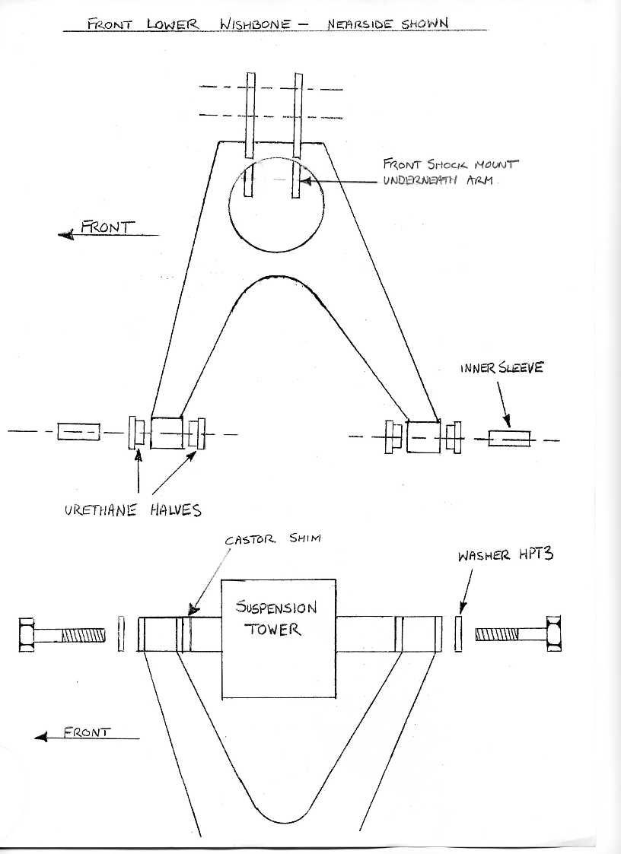

- Page 5 –
DRAWING No. TMX002
Front upper wishbone – offside shown
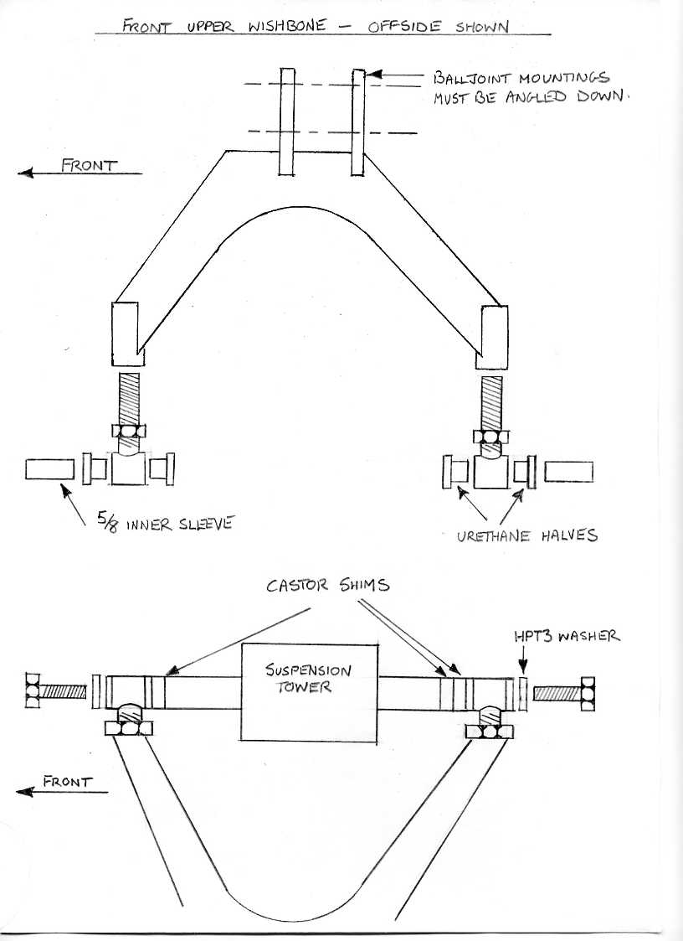

- Page 6 –
ASSEMBLE & FIT THE FRONT UPRIGHTS

From the donor vehicle you will need the following parts which should be clean and ready for assembly:

Front wheel mounting flanges
ABS Rotor
Hub dust covers

New wheel bearing kits, discs and brake calipers should be purchased.

Start by pressing the bearing outer faces into the aluminium uprights, pack both bearings with grease, place the outer bearing into the hub and carefully tap the outer seal into the recess in the aluminium uprights. Push the wheel mounting flange through the bearing and turn the whole assembly upside down so that the rear bearing followed by the ABS rotor can be installed; fit the large nut and tighten to 220lb ft.

Note that the wheel mounting flange threads are right and left hand thread so ensure that you are fitting the correct nuts. Left-hand thread on the right-hand hub use a lithium based grease and make sure the seal lips are greased; the rear dust seal can now be fitted.

The front upright assemblies can now be fitted to the wishbones previously fitted to the chassis.
Fit the upright assemblies onto the ball-joint pins – See Drawing No. TMX003; there are four flat oblong washers supplied with the chassis kit, these are fitted to the ball-joint pins prior to the securing nuts being fitted – they are designed to help spread the load when doing up the ball-joint nuts. The slightly longer of the washers is fitted to the upper ball joint.

The front disc and front brake caliper can now be fitted, the brake caliper lower mounting also holds the steering are rear mounting. The front of the steering arm is bolted directly to the aluminium upright, all the bolts for the above are supplied in the bolt kit. NOTE: The tapered boss on the steering arm should go to the bottom – see Drawing No. TMX004.

- Page 7 –
DRAWING No. TMX003
Front upright/ ball-joint washers
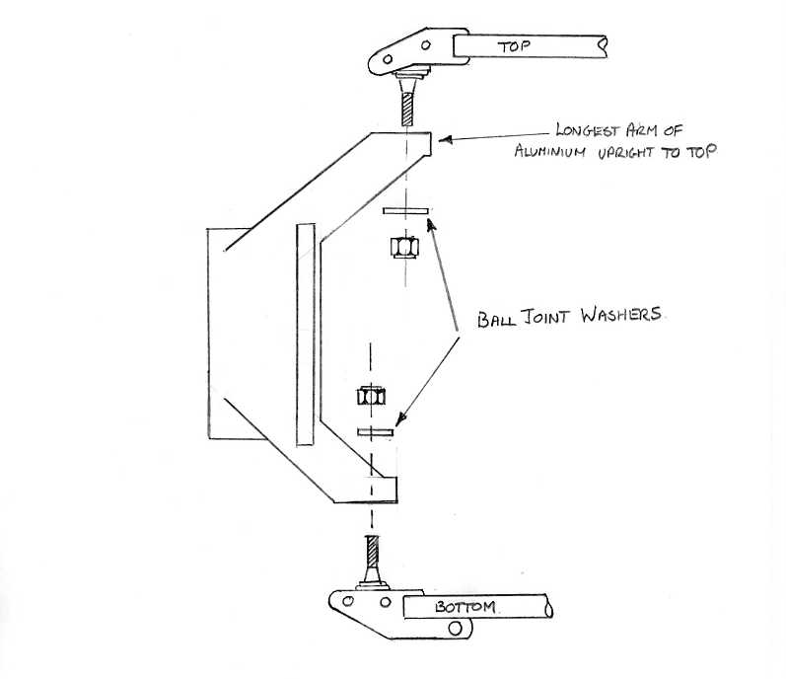
DRAWING No. TMX004
Fitting the steering arms to the front hub
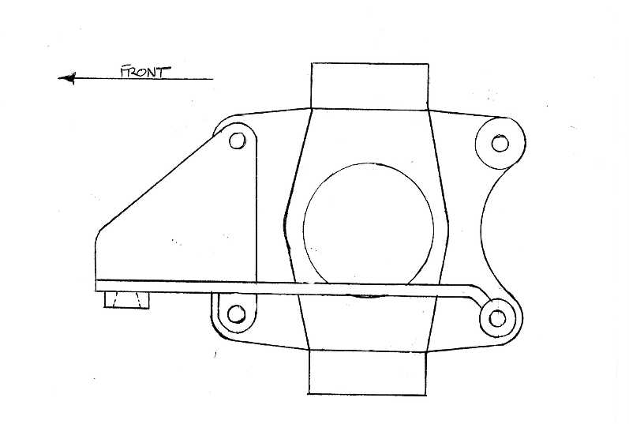

- Page 8 -
FITTING THE STEERING RACK

The steering rack is bolted to the front of the front crossmember, between the front suspension towers. There are two spacers provided with the kit; these fit between the bottom of rack and the rack lever mounting on the chassis – See Drawing No. TMX005 - bolt into position with the bolts provided in the fastener pack.

DRAWING No. TMX005

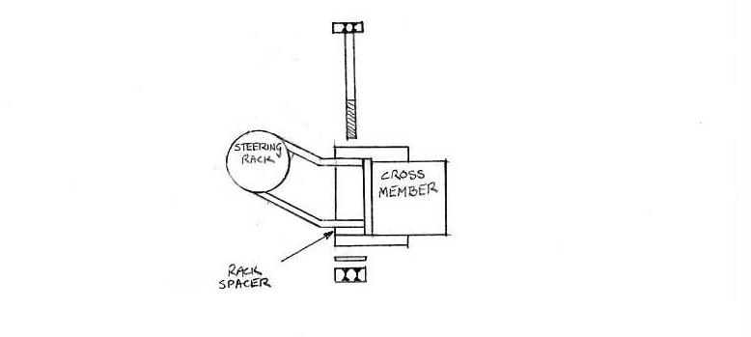

- Page 9 -
ASSEMBLING THE REAR SUSPENSION

Press the urethane halves and 1/2” inner sleeves into the rod ends, fit the 5/8 UNF locknuts and the threads with COPASLIP, the rod ends can now be screwed into the top and bottom wishbones – See Drawing No. TMX006 & TMX007 to determine the correct orientation of the wishbones.

With approx. 10mmm of thread showing on the rod ends, the wishbones can now be bolted to the chassis, leave the nuts loose for now as a small adjustment may be required to the rod ends to allow alignment of the bolts holding the rear upright assembly.

Once the wishbones are fitted to the chassis the rear shock absorber assembly can be fitted. They are bolted to the chassis at the top and bolted to the lower wishbone with the spacer towards the front. The shock damping adjuster should also be fitted towards the front.

With the wishbones now fitted the differential and rear hub assemblies can be fitted.

- Page 10 -
DRAWING No. TMX006
Rear upper wishbone – nearside shown
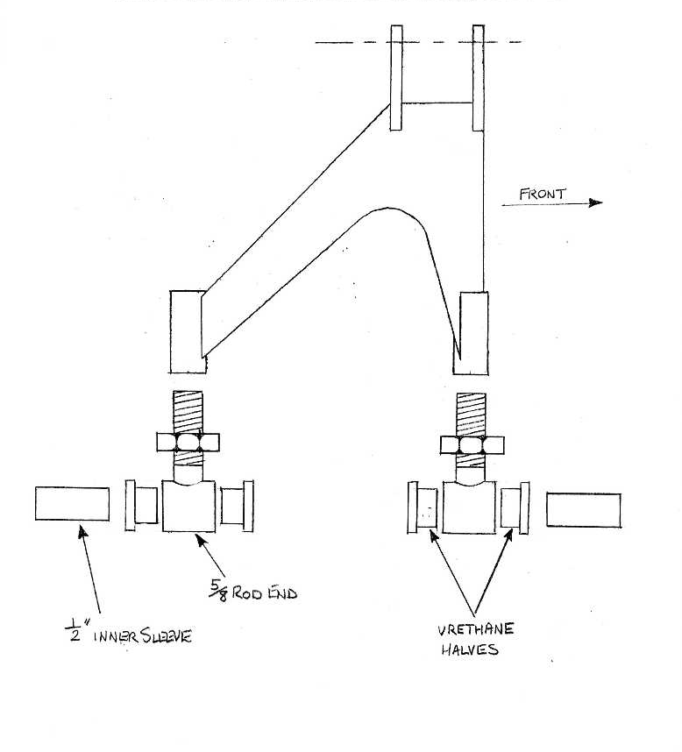

- Page 11 -
DRAWING No. TMX007
Rear lower wishbone – nearside shown
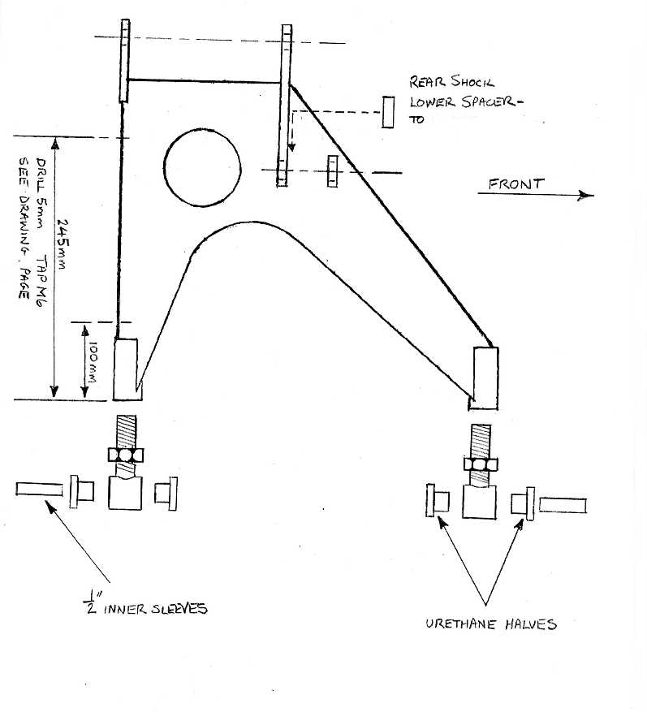

- Page 12 -
DRAWING No. TMX008
Shock Spacer positions

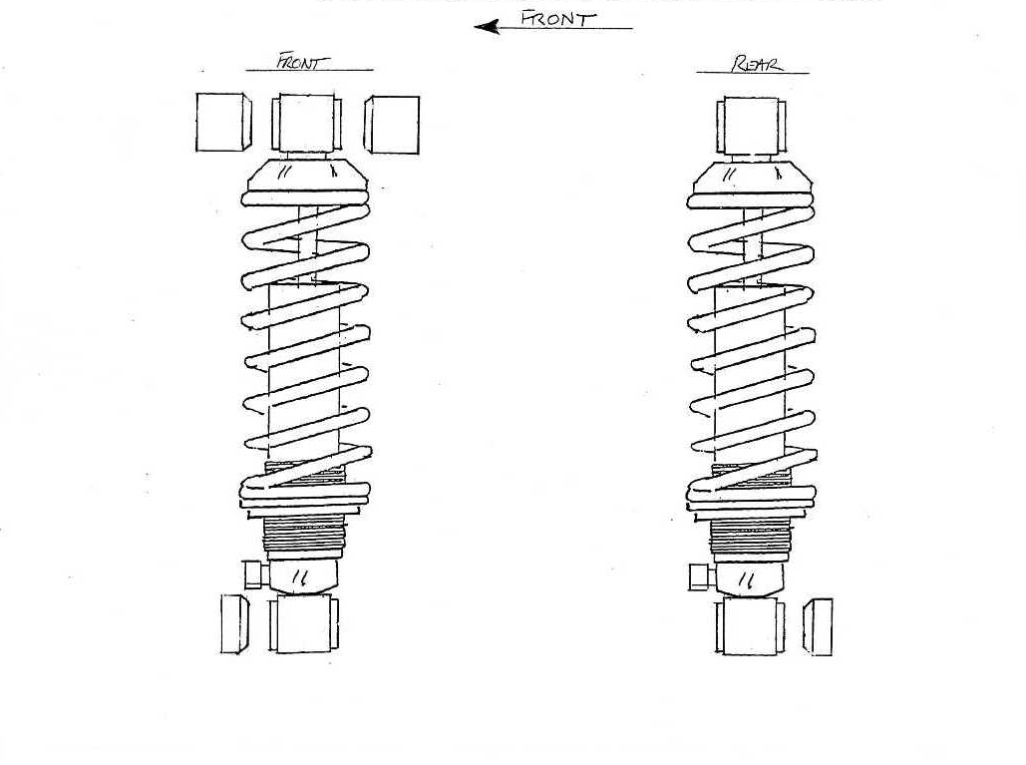

- Page 13 -
FITTING THE DIFFERENTIAL

Slide the diff under the chassis and lift it straight up into position, block it up with wood to support whilst the mountings are fitted. Gather together the spacers and bolts from the fasteners kit and study Drawing No. TMX009 which shows their location. The diff mountings are supplied from Sebring International with their mounting bushes already fitted.

Start by fitting the side mountings; loosely assemble them to the diff and then lift the diff up into position whilst locating the diff mount bushes into the mounting brackets on the chassis – a soft mallet may be required to assist with the location of the bushes. Fit the mounting bolts through the bushes and tighten. The diff rear mount can now be fitted – See Drawing No. TMX 009 – finally tighten all diff mounting bolts.

- Page 14 -
DRAWING No. TMX009
Differential – nearside view

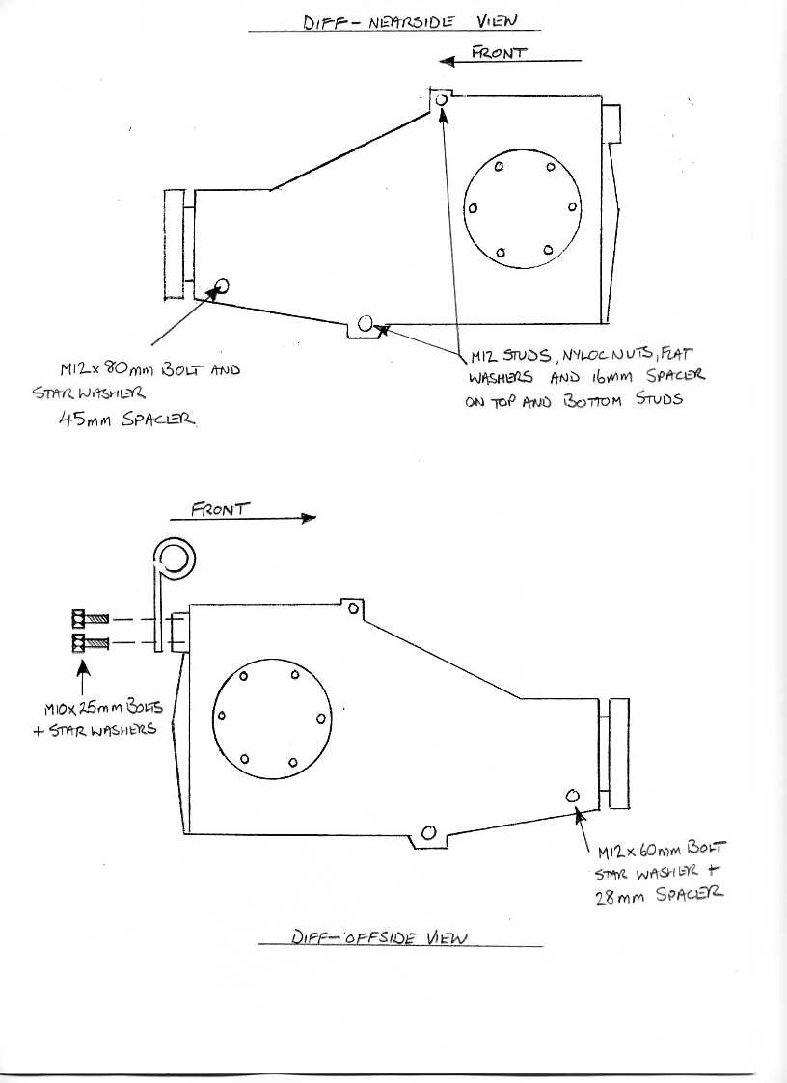
Differential – offside view

- Page 15 -
ASSEMBLING THE REAR HUBS & UPRIGHTS

Press the urethane halves into the uprights, followed by the bushes. The hub bearing carrier from the donor vehicle can now be bolted to the upright. Use Locktite on the bolts. The hub flange, extension shaft disc and caliper can also be fitted, it is strongly recommended that all parts are fully reconditioned or exchange units fitted. Tighten the hub nuts to 220lb per ft.

IMPORTANT The left-hand (nearside) upright uses the hub nut with a left-hand thread. The uprights are sided – See Drawing No. TMX010 for details. The brake clippers are fitted to the rear with bleed nipples and handbrake actuator to the top.

DRAWING No. TMX010
Rear upright – nearside shown
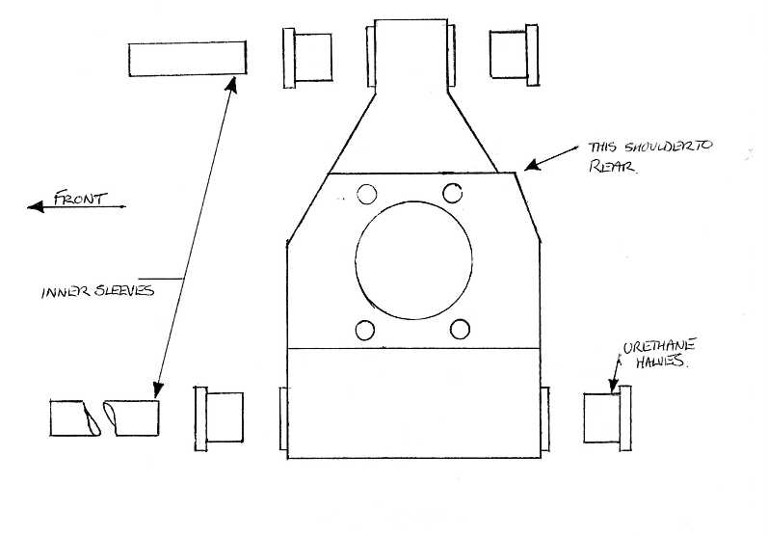

- Page 16 -
FITTING THE UPRIGHTS TO THE WISHBONES

The assembled uprights can now be fitted to the wishbones, they are a straight forward bolt-on using bolts from the fixings kit supplied. Once the uprights are fitted the drive-shafts can be installed; it is recommended that these are exchange over-hauled units and that the TORX type of bolts used to bolt the drive-shafts are also replaced with new items – your local Ford Dealer should be able to source these for you. These should be torqued to 28-32 lb per foot.

FINAL CHASSIS SET-UP

This should be done when the car is fully built and the sat on its wheels; the tracking and camber should be adjusted to the following specs:

Front Tracking - 2.5mm Toe in
Rear Tracking - 1mm Toe in
Camber - 1/4 Degree Negative - Front & Rear

Damping adjustment on shocks:

Front - 3 Clicks
Rear - 8 Clicks

These are basic settings and can be altered to suit your driving requirements.

- Page 17 -
FITTING THE HANDBRAKE LEVER & CABLE

The handbrake lever is fitted to the top of the transmission tunnel with the rear mounting lug sitting on top of the tunnel and the front mounting lug mounted below the tunnel – use the 8mm nut supplied in the fastener kit as a spacer between the tunnel and the front mounting lug to move the handbrake lever down even further.

The cable supplied with the Sebring kit can now be fitted; leave one nut, spring washer and flat washer on each of the two outer cable adjusters – the remaining nuts and washers are left loose on the inner cable. Pass the inner cable and loose nuts etc., through the large hole in the centre of the handbrake cable mounting plate at the rear of the tunnel.

Next push the outer cable adjusters through the two outer holes; once through fix them into position by fitting the nuts and washers which were left loose on the inner cable. The inner cable can now be attached to the handbrake lever using the original equaliser and pin from the donor vehicle.

The cables should be routed over the top of the diff, down the rear of the diff, between the diff and rear crossmember and under diff carrier side members, then along the rear edge of the lower wishbones where it is secured by p-clips. The cable then passes up through the cable lug on the rear calipers to the actuating arm – See Drawing No. TMX011 & TMX012 which show the routing of the cable, cable adjuster and position of the cable securing clips on the lower wishbone.

- Page 18 -
DRAWING No. TMX011

Handbrake cable routing
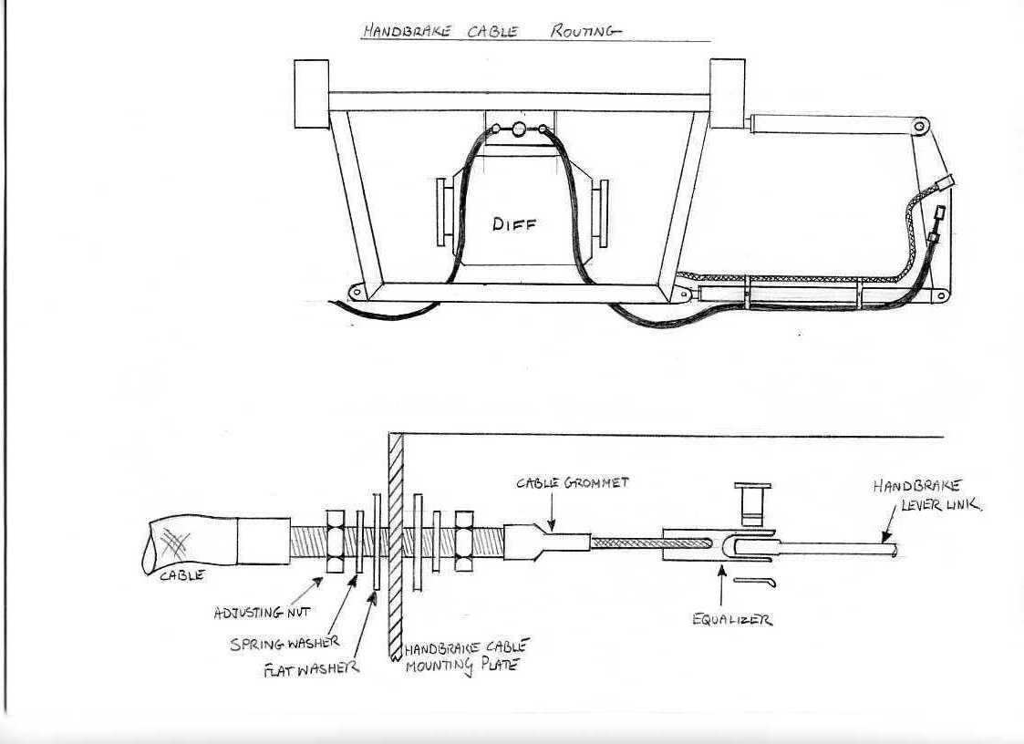

Handbrake cable adjuster

- Page 19 -
DRAWING No. TMX012

Hole position for clamping handbrake & flexible brake pipe
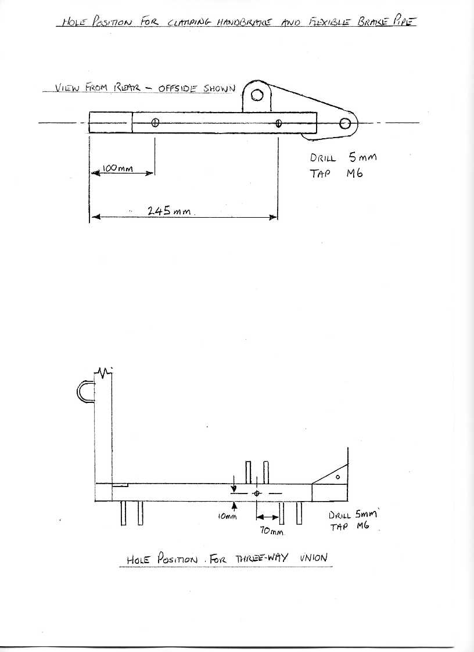
Hole position for three-way union

- Page 20 -
FITTING THE BULKHEAD MOULDING

DRAWING No. TMX013

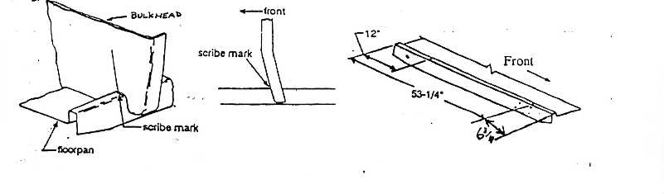

The front bulkhead as supplied by Sebring now comes with all he relevant holes already cut out or drilled. If the bulkhead is to be painted it must be done at this stage before fitting to chassis.

With a wax pencil mark a line across the top face of both chassis side sills 6.3/4” from the front edge. The bulkhead moulding can now be positioned over the chassis with the front face of the moulding level with the line. From behind the bulkhead drill a 3/16” hole down through the fibreglass flange into the top of the chassis side sill and fix the bulkhead temporarily in position with a large head pop rivet on each side. DO NOT ATTEMPT TO FIX THE BULKHEAD FURTHER UNTIL THE FRONT CLIP HAS BEEN INSTALLED.

- Page 21 -
FITTING THE BONNET HINGES

Fit the hinges as high as possible in the bulkhead until the rear part of the hinge carrier is butting up to the bulkhead return flange. The through bolts should be cut off as short as possible after the nyloc nut has been fitted and tightened to avoid fouling the hinge cover panels fitted later – see Drawing No. TMX014

DRAWING No. TMX014

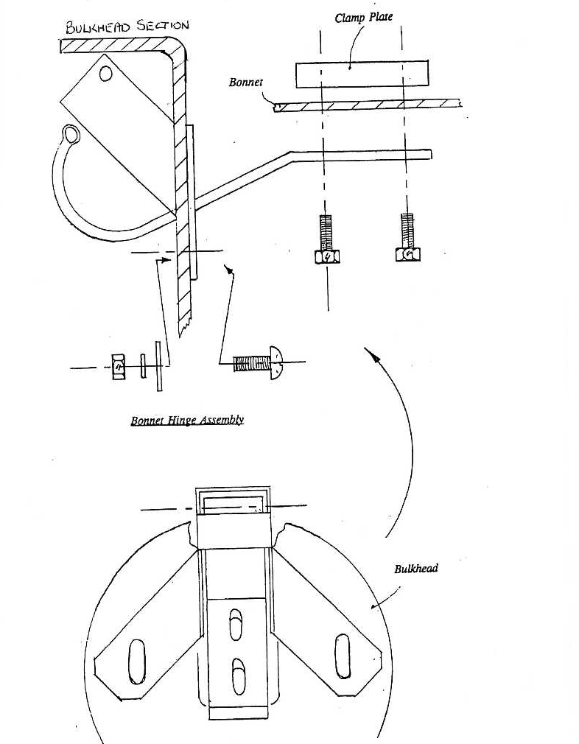
- Page 22 -
FITTING THE PEDAL BOX

The pedals on the Ford pedal box require welding 20mm to the left, measured at the centre of the footpad. As this will require the use of a TIG Welder it is best left to a professional – Sebring International can carryout his work if required.

The clutch pedal also requires a further modification – see Drawing No. TMX015. Disassemble the pedal box, being careful to note the position of the various spacers and clips, throw away the yellow quadrant and spring from the top of the pedal and automatic cable adjuster – you will only need the bare pedal, two red bushes and the pedal pad.

Now re-assemble the pedal box, the bolt-on bracket for the original clutch cable will require some material to be cut from the corner near to where the clutch cable tube is fitted (the amount to be removed will be evident as you fit the pedal box assembly). The original clutch cable tube can the be shortened by 25mm – a hole can then be drilled through the bulkhead (10.5mm), when bolted up his will act as an extra brace for the pedal box.
DRAWING No. TMX015
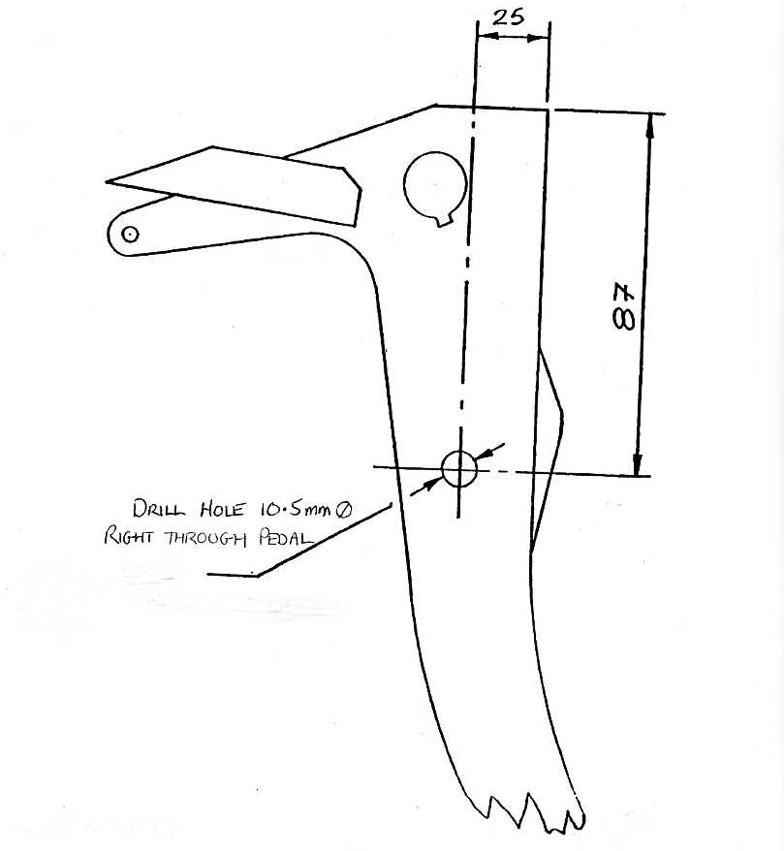
- Page 23 -
DRAWING No. TMX016

Pedal box assembly
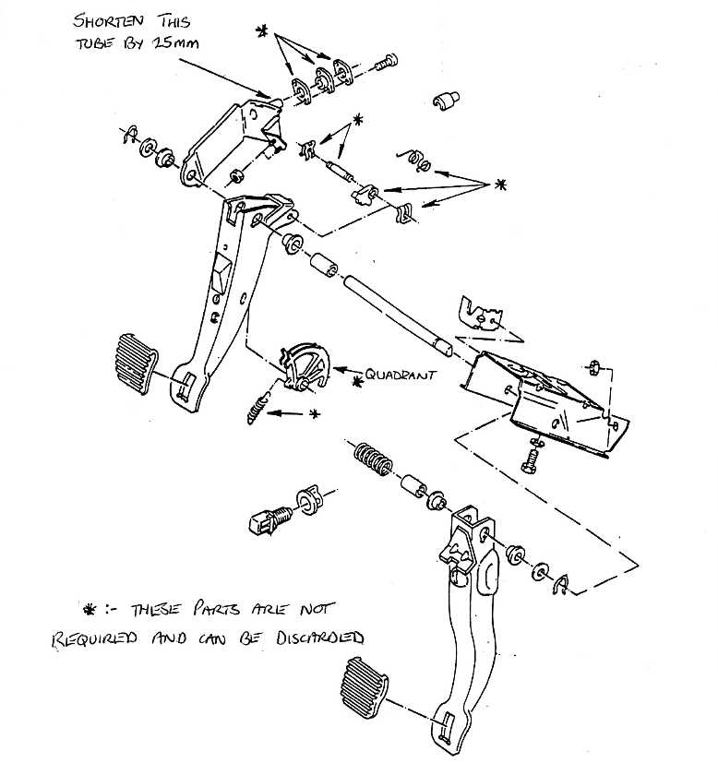
An aluminium spacer is fitted between the top of the pedal box and bulkhead. This requires a hole (12mm) to be drilled in the bulkhead in line with the slot in the top of the pedal box. Once the hole position has been determined the pedal box will have to be removed to drill this hole.

Bolt the pedal box and servo back into position. Loosely bolt the spacer and cap into position (See Drawing No. TMX016). Do not tighten as this will have to be removed to fit the pedal box to scuttle bar brace between the spacer and pedal box later. Do not forget to fit the master cylinder to sill brace and scuttle bar to pedal box brace once the body has been fitted.

- Page 24 -
DRAWING No. TMX017
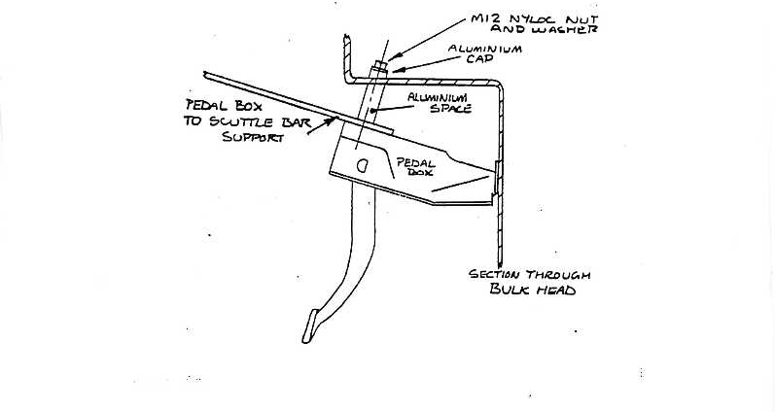
The hydraulic clutch master cylinder can now be fitted, place the cylinder through the bulkhead and bolt in position using bolts and nuts supplied in bolt kit.

Now place the modification shaft through the previously drilled hole in the clutch pedal, not forgetting the spacer to prevent the pedal from crushing when tightened. The shaft uses an M10 nyloc.
Now fit the clutch push rod extender, not forgetting to use a 5/16” UNF plain nut to lock the push rod against the extender.

The Hydraulic line from clutch master cylinder to the slave cylinder is a continuous stainless steel braided flex.

The banjo end is bolted to the master cylinder, be careful not to over tighten as the master cylinder casing as aluminium and the threads are easily stripped. Ensure you use the two copper washers either side of the banjo. Clip the flexible hose to the bulkhead for neatness.

- Page 25 -
FITTING THE BATTERY TRAY, HEATER INLET, FUSEBOX
& WIRING LOOMS

Fit the battery tray to the top of the ledge on the left of the bulkhead moulding with the three M6 roofing bolts and nyloc nuts provided in the fastener package. Place the battery on the tray, the battery clamp and the clamp bolts will need shortening.

Disconnect the wires from the fuse box; mark the green and white wires at the bottom of the fuse box with a piece of tape. This is so they will not be confused with the green and white wire directly above them in the fusebox.

The fusebox is fitted from rear of the bulkhead and secured by two M5 x 16mm cap head screws from the front.

The wiring looms are supplied with two rubber grommets, fit these into the two holes below the fusebox.

Carefully thread the front harness through the upper of the two holes and reconnect the fusebox wiring – See Drawing No. TMX024. The lower of the two holes is for the engine harness and windscreen washer pipe to run through.

The two relays on the front harness can be riveted to the bulkhead adjacent to the fusebox.

The heater air inlet is fitted to the left hand side of the bulkhead, fit the double inlet plate through the two pre-cut holes and rivet into position using 1/8” x ½” rivets – a small bead of silicone sealer may be used to ensure the inlet plate seals against the bulkhead. It may be necessary to radius the outermost top corner of the inlet plate where it overhangs the bulkhead.

The insulated post for the wiring looms can also be fitted at this stage - See Drawing No. TMX018 which shows the insulated post position.

- Page 25 -
DRAWING No. TMX018

Position of insulated post
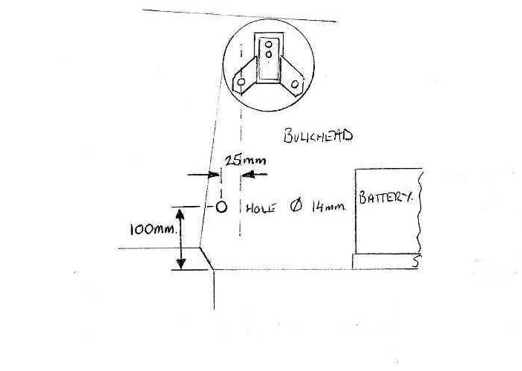

- Page 26 -
FITTING THE FUEL TANK, FUEL PUMP & FILTER

The fuel tank is secured to the chassis with two stainless steel straps. Before fitting, cut a length of self-adhesive foam strip and attach to the upper face of the straps to avoid ay chafing of the tank.
A small piece of the same foam strip should also be stuck to the bottom of all four tank locating brackets before the tank is lifted into position and secured.

The hooked end of the strap loops over the hoop under the rear of the chassis and the bolt attached to the other end is passed up through the innermost hole of the two drilled in the tank mounting bracket.

Drawing No. TMX020 shows the position of the fuel pump which must be mounted on rubber isolators to avoid undue noise inside the car. The chassis will need to be drilled and tapped 5/16” UNF to accept the treaded end of the isolators, use the pump as a pattern for the position of the holes when using a Facet fuel pump. An inline fuel filter should be fitted in the fuel line between the fuel tank and fuel pump.

Sebring recommend the following fuel pumps:
Facet silver top – competition - up to 150BHP
For which you will also require two 90 degree brass Unions and 1/8” NPTF with 8mm tails.
Facet red top – works – up to 200BHP +
For which you will also require two 90 degree brass Unions and 1/4” NPTF with 8mm tails.
Holley blue pump & regulator – for 200 – 500 BHP
For which you will require 3/8” NPT adaptors to 3/8” ID fuels hose

Fuel injection:- The fuel tank for fuel injected models differs from carburettored models in that it has an extra flange/ mounting in the top of the fuel tank to allow fitment of a submerged injection fuel pump . The pump required is a Range Rover 3.9 litre 1990/91 pump and the fuel filter from the same vehicle should also be used and fitted on the left-hand main chassis rail – See Drawing No.TMX019.

- Page 28 -
DRAWING No. TMX019
Fuel system – Fuel injection

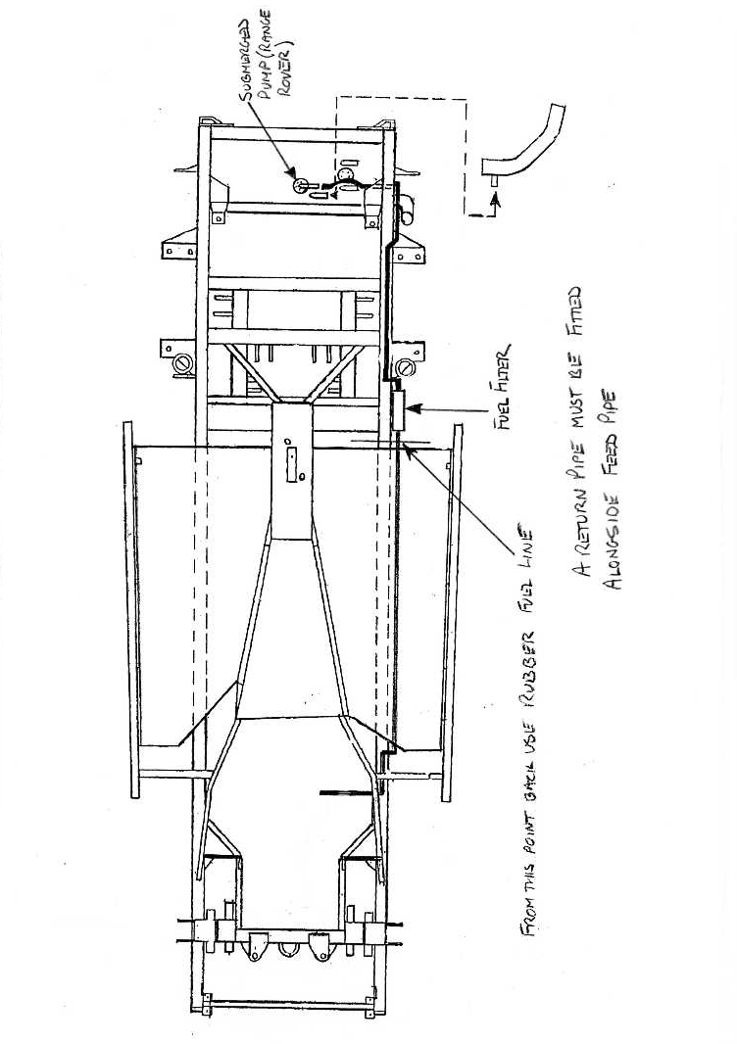

- Page 29 -
DRAWING No. TMX020
Fuel system - Carburettor

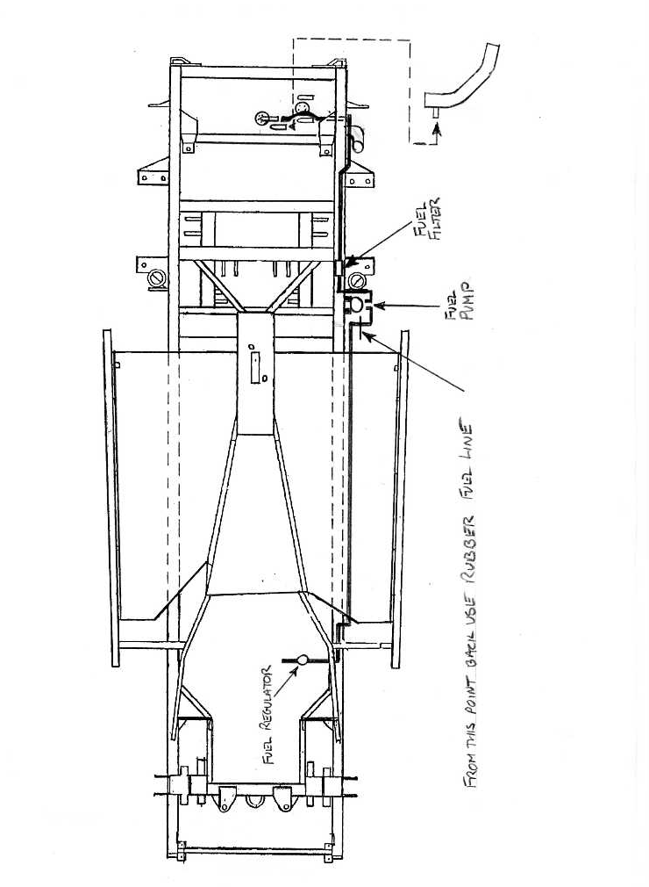

- Page 30 -
FITTING THE FUEL LINES

Before commencing with fitting the fuel line(s) it is advisable that you purchase a suitable hand-held pipe bender which has the capacity for 3/16” brake pipes and 5/16” fuel pipes – the pipes can be bent by hand CAREFULLY but a pipe bender will lessen the risk of kinked pipes.

The fuel pipe(s) are routed alongside the left-hand chassis rail, under the floor pan, through the cut-outs in the chassis outriggers. Use the rubber lined P clips provided in the fuel pipe kit and secure by drilling a 4mm hole and using the self-tapping hex headed screws provided. The fuel lines should be secured approximately every 8” to 9” and if using fuel injection a second pipe must be fitted immediately beside the feed pipe. If running two pipes screw clips to floor pan – if running a single pipe this can be clipped to the chassis rail; sand down any protruding screws through the floor pan.

Drawing No. TMX016 & TMX017 show the pipe routing and position on the fuel system components.

The rubber fuel line can now be connected between the various components, use the hose clips provided in the kit and secure the rubber fuel pipe with the rubber lined P clips and self-tapping screws as described above.

The tank sender unit for the fuel gauge can now be fitted and is supplied with instructions for setting up the correct length on the float arm – FOLLOW THESE INSTRUCTIONS CAREFULLY.

The sender unit should be positioned with the float swinging up towards the rear of the tank. The screws must be tightened down evenly to compress the cork gasket properly – use copper washers.

Tape over the tank filler neck to avoid any dirt ingress and blank off the spare return pipe if not using fuel injection.

- Page 31 -
FITTING THE BRAKE PIPES

Fit the master cylinder and servo assembly to the bulkhead, it passes through the bulkhead from the front, through the pedal box and is secured with two M10 nylocs and washers. DO NOT forget to fit the small nylon bush on the servo rod before it comes through the brake pedal. The Sebring clip is fitted once the servo rod is through the pedal.
The sill to master cylinder brace can now be fitted; it is bolted to the top of the sill and then bolted to the outermost master cylinder mounting stud on the servo after the master cylinder has been fitted.

Fit the front and rear flexible hoses, the fronts are fitted to mounting lugs on the underside of the chassis rails behind the front suspension towers. The rears are fitted to brackets welded to the rear of the diff carrier. The rear pipes are then clipped to the lower rear wishbone before fixing to the caliper.

The copper brake pipes are secured by the black plastic clips supplied with the kit. Drill a 5mm hole and insert the base of the clip, the top half should then be tapped down into the lower section to expand and secure the assembly in the hole. A tool to assist in fitting the clips can be made from a piece of 25mm x 30mm steel, which should be approx. 100mm long.

See Drawing No. TMX012 which shows the mounting position of the three-way connector and the position of the rear flexible pipe P-clips on the lower rear wishbones.

Key to Drawing No. TMX021
Pipe No.
1 | Master cylinder – connector (rear line)
2 | Rear line connector – 3-way connector
3 | 3-way connector – offside rear flexible pipe
4 | 3-way connector – offside front flexible pipe
5 | Master cylinder front lower port – offside front flexible pipe
6 | Master cylinder front port – nearside front pipe connector
7 | Nearside front pipe connector – nearside front flexible pipe
- Page 32 -
DRAWING No. TMX021
Brake pipe routing
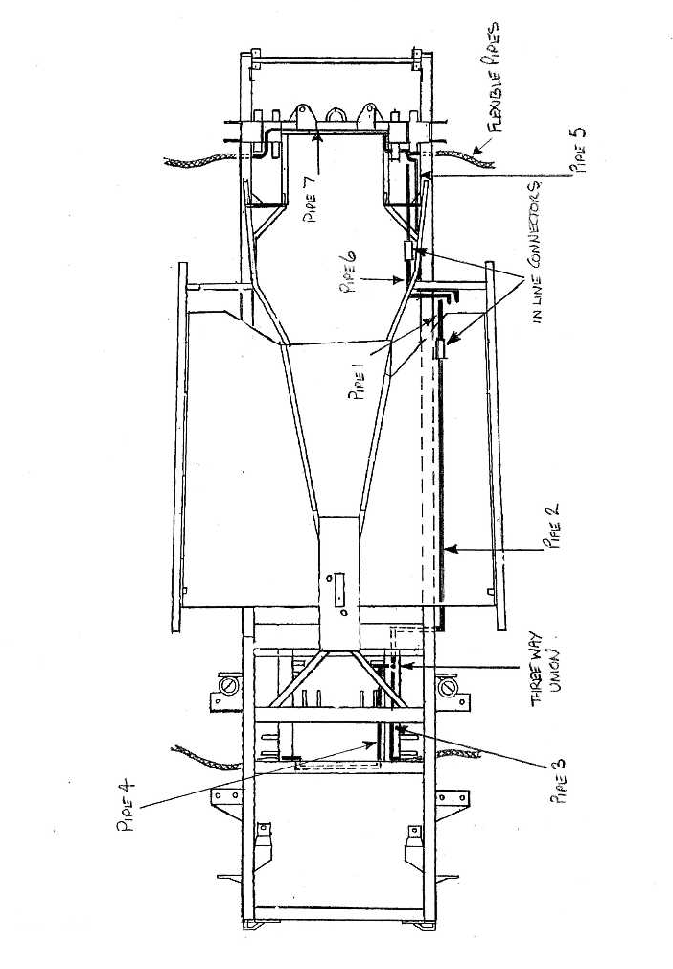

- Page 33 -
DRAWING No. TMX022
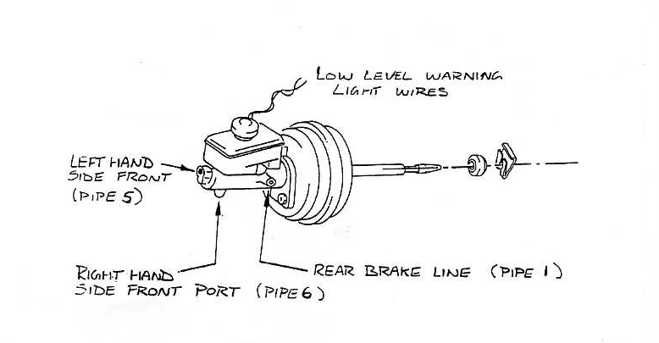

- Page 34 -
DRAWING No. TMX023
Mounting sill – Master cylinder brace
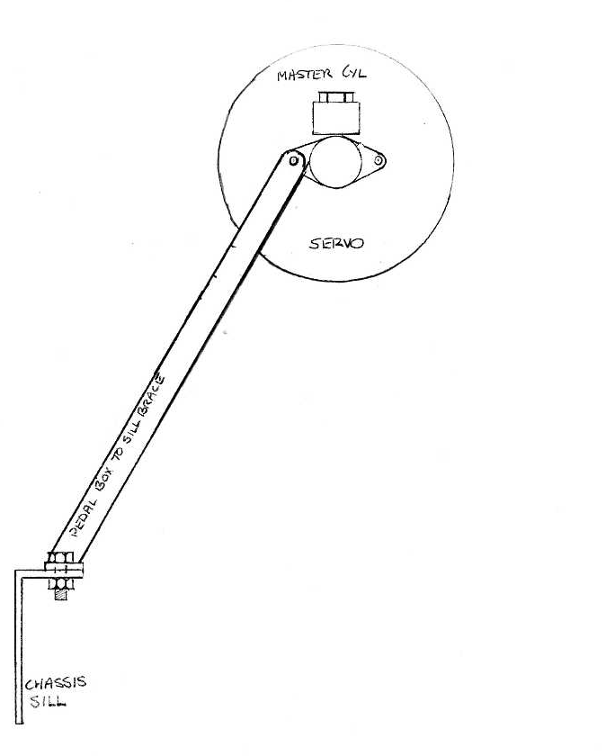

- Page 35 -
DRAWING No. TMX024
Routing of wiring loom
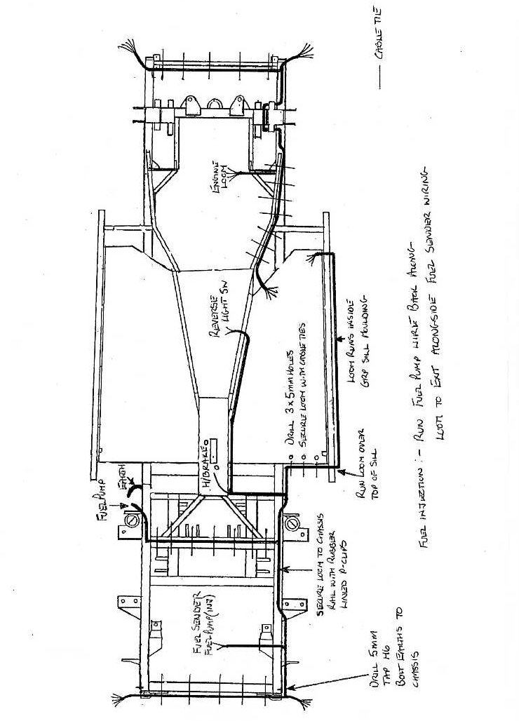

- Page 36 -
FITTING THE WIRING LOOMS

Start with the rear loom first – See Drawing No. TMX024 which shows the routing of the loom.
Cable tie the loom across the rear crossmember, the loom then runs along the offside chassis rail towards the top of the rail. At the point of the seat belt post rear mounting the loom is then routed to the top centre of the chassis rail and then back down to the side immediately after it passes the front mounting for the seat belt post. It then follows along the chassis rail and along the rear of the floorpan – drill three 5mm holes and secure with cable ties. The loom then comes over the top of the chassis sill and along the sill and can be held in position by tape.

The GRP sill mounting will eventually dictate the position of the loom where it runs along the sill.
The loom finally comes back over the sill into the car at the position where the main door post is fitted.

The front loom and engine loom are cable tied to the chassis brace which runs from the tunnel to the chassis rail. Keep it to the outside of the brace. At the point where the brace joins the top of the chassis rail the loom is routed on top of the chassis rail and then round the suspension and back along the top of the rail. Run the front section of the front harness along the back of the front crossmember and cable tie in position. Any excess wire can be cable tied to the radiator frame upright (right-hand side).

The earth wires on the front harness can be bolted to the radiator frame uprights; the rear harness earths will need a 5mm hole to be drilled and tapped (M6) on the outside of both chassis rails approx. 75mm from the rear of the chassis – clean any powder coating off the ensure a good earth.
The engine harness can be coiled up at the point where the tunnel to chassis brace meets the chassis until the engine/ gearbox unit is installed.

Run the fuel pump wire across the top of the main diff mounting crossmember, cable tie into position and connect to the pump. A small earth lead will need to be made to earth out the fuel pump. A 5mm hole will need to be drilled and tapped (M6) into the side of the chassis close to the pump, fit the lead from the hole to one of the fuel pump mounting nuts.

- Page 37 -
Run the handbrake warning switch wire and reversing light switch wire from the rear harness over the chassis rail and along the crossmember immediately behind the tunnel/ floor, at the point where the wiring meets the tunnel run it down inside the car and alongside the tunnel – it can be coiled up and left until required later in the build.
If you are fitting a radio, a 2.5 metre aerial extension lead should be cable tied to the loom at this stage. The aerial end should be positioned at the point where the rear floorpan meets the sill, it then runs along the sill and up into the car at the doorpost.

Drawing No. TMX025
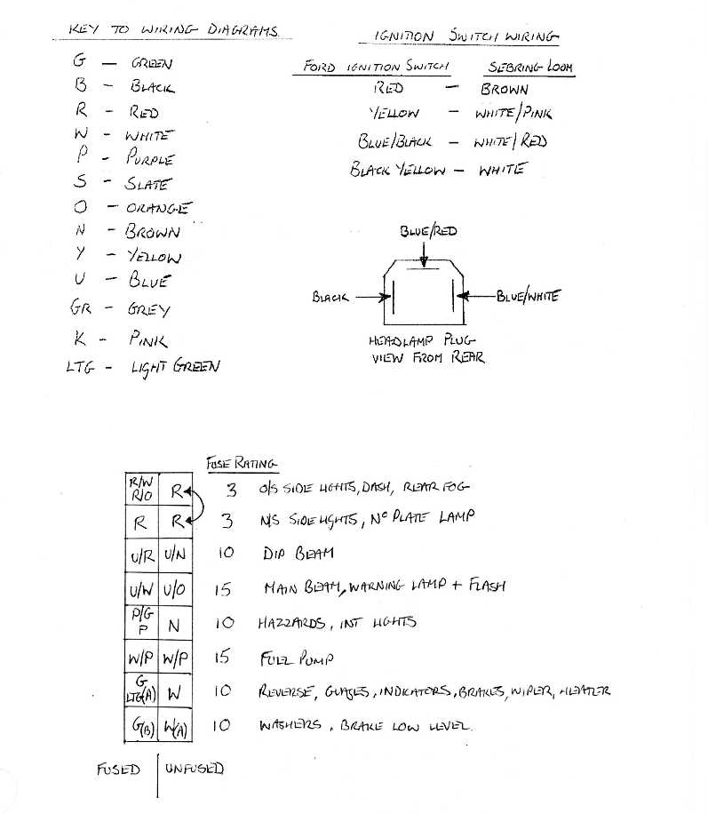
- Page 38 -
Drawing No. TMX026
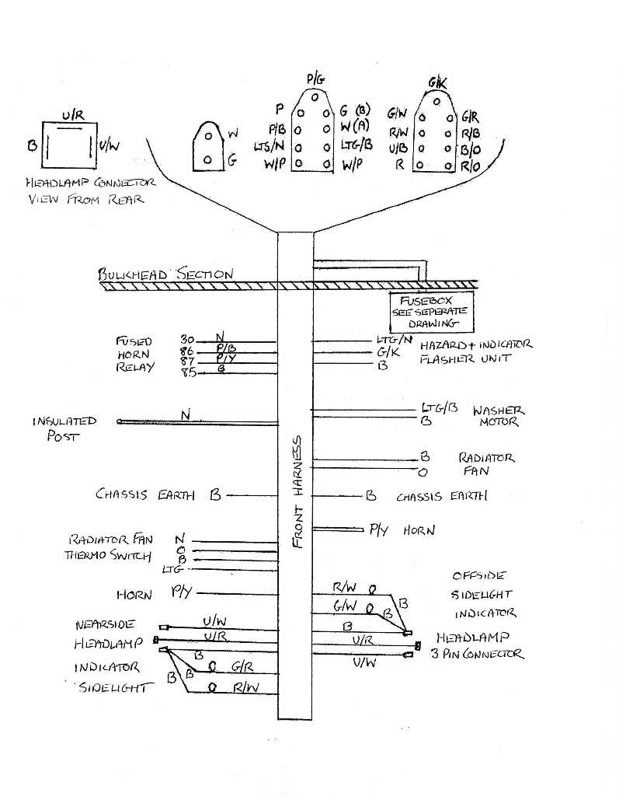

- Page 39 -
Drawing No. TMX027
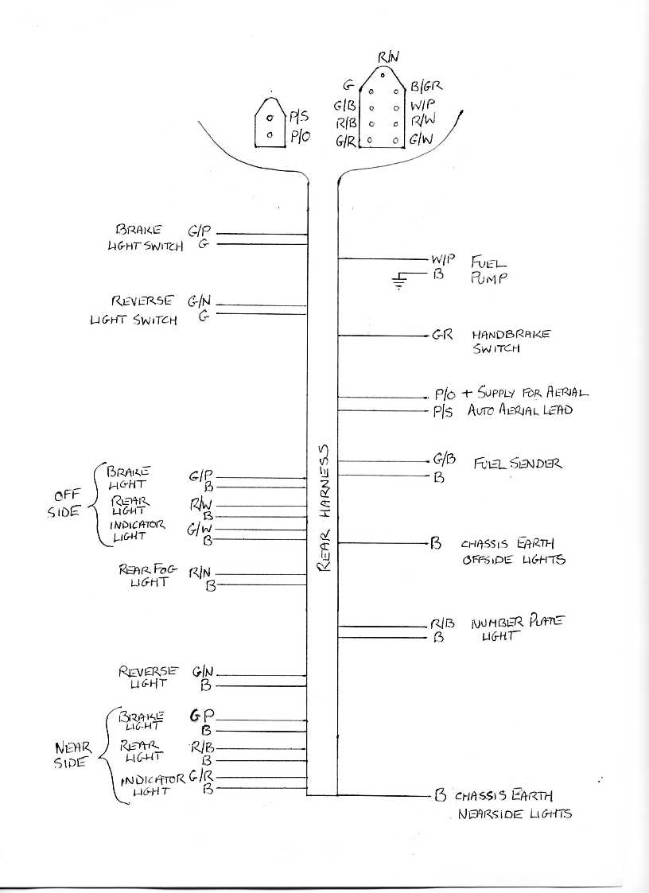

- Page 40 -
Drawing No. TMX028
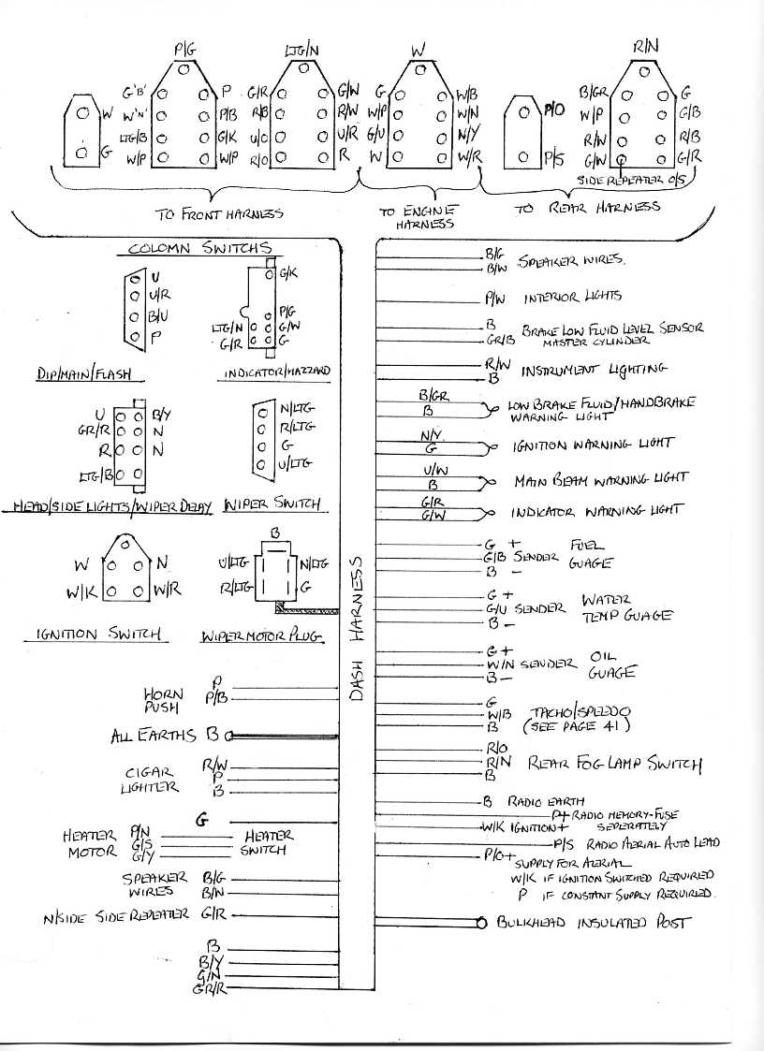

- Page 41 -
Drawing No. TMX029

Speedo/ Tacho wiring – Smiths Telematrix range
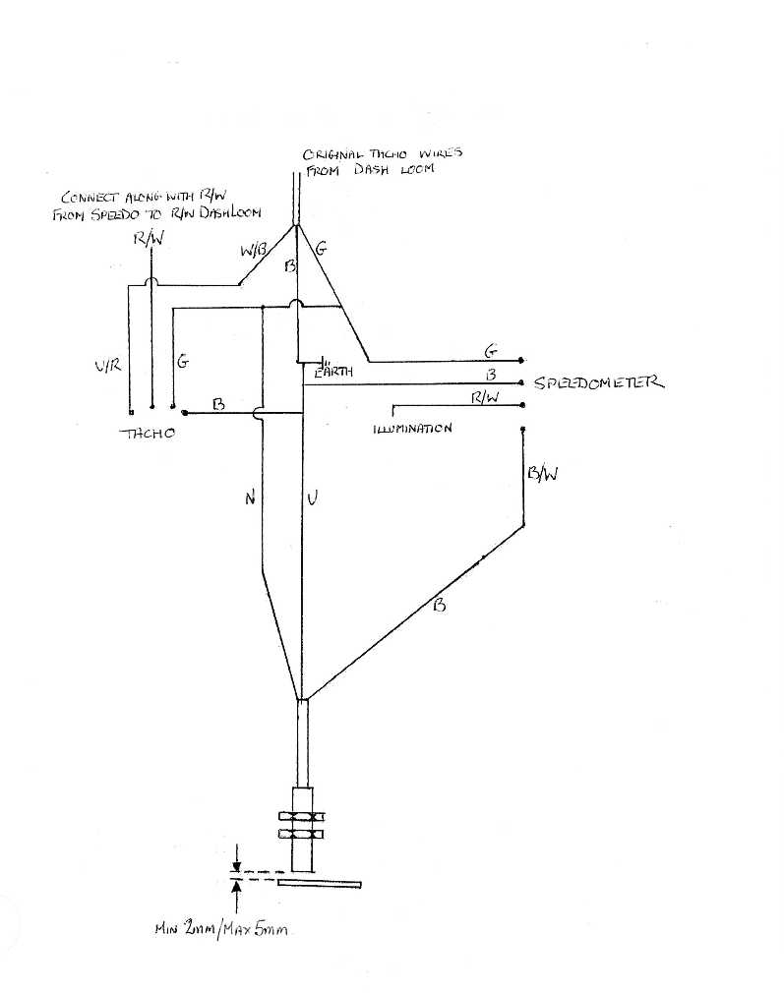

- Page 42 -
Drawing No. TMX030

Electric window harness using Sebring window switches

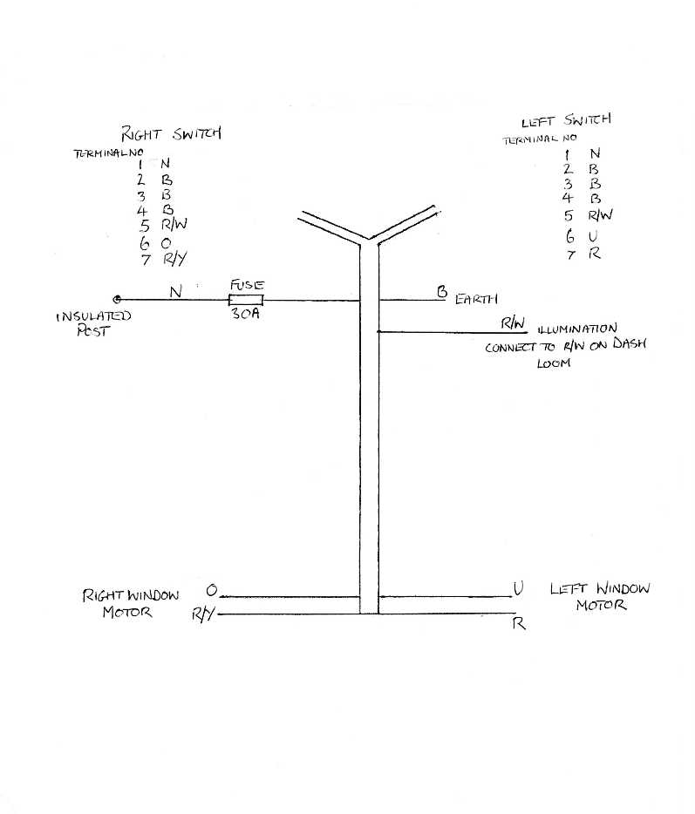

- Page 43 -
Drawing No. TMX031

Electric window harness using Ford window switches
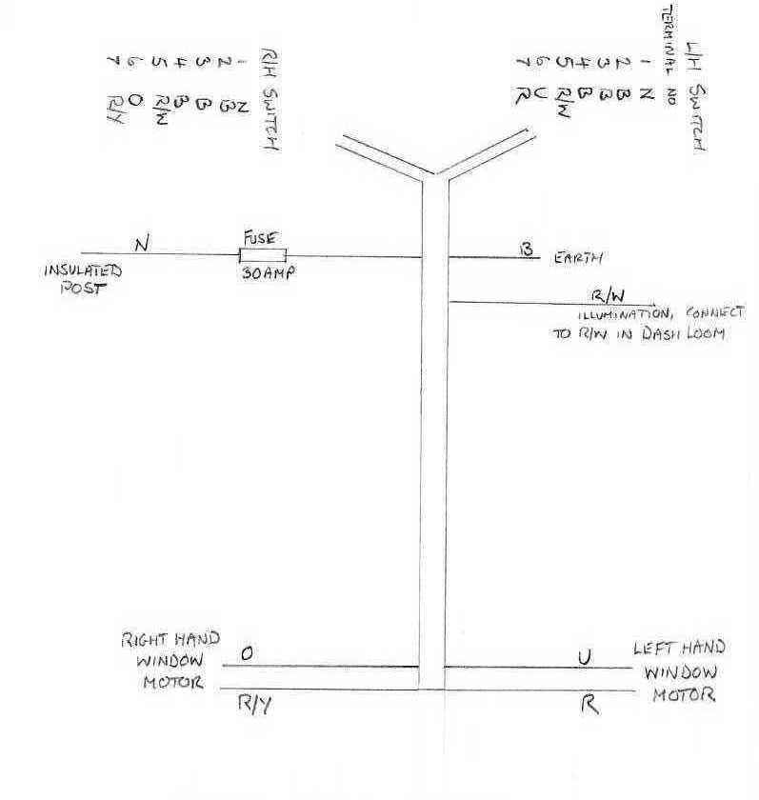

- Page 44 -
Drawing No. TMX032

Interior lamp wiring using door switches
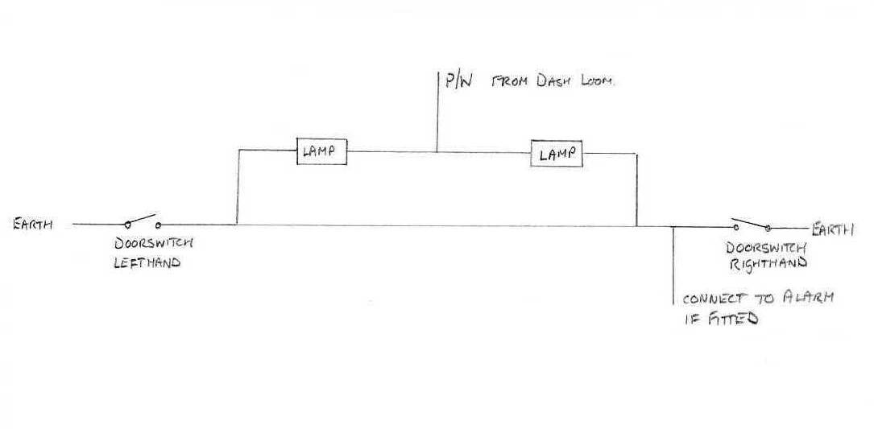

ASSEMBLING THE DOOR POSTS

The door posts, door jamb brackets and hinges are handed so study Drawing No. TMX034 CAREFULLY before starting work to ensure you are fitting the correct parts to the corresponding side of the car.

Locate the two drill holes needed to secure the bottom of the main door post to the chassis side sill and drill through the inner face of the sill using the outer hole as a guide. Insert two sill spacer tubes supplies in the fastener pack up into the sill section and pass two bolts with washers through the sill and spacers from inside the car and place the door post onto the bolts before fitting washers and retaining nyloc nuts to the outside. The spacers will stop the hollow sill section from being crushed when the bolts are tightened. The post should be placed midway along the slotted adjustment holes as a starting point for adjustment.

- Page 45 -
Drawing No. TMX033

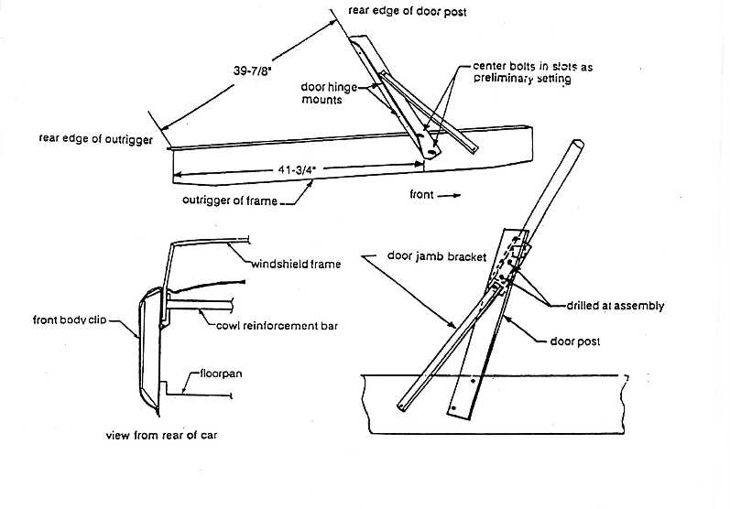
The door jamb bracket can now be bolted to the outer face of the sill only and positioned over the upper mounting plate on the door post. The upper fixing should not be drilled yet as the door post may require considerable adjustment to align the doors.

The hinge mounting plate can be bolted onto the door post with M8 bolts, plain and shake-proof washers and the hinges attached to the plate with long hinge bolts supplied. Use plenty of COPASLIP grease on the hinge bolts to avoid squeaky doors in the future.

The scuttle support bar is now bolted to the top of the door posts using M10 x 25mm bolts inserted from inside the car facing outwards.

The lower door post bolts and the scuttle bar securing bolts should be nipped up but not fully tightened at this stage to allow the door post angle to be changed for door alignment.
Do not fit the transmission tunnel to scuttle bar brace yet as it will lock the scuttle bar position and not allow for later adjustment when the steering column is fitted.
- Page 46 -
Drawing No. TMX034

Door post/ Hinge assembly – Nearside shown
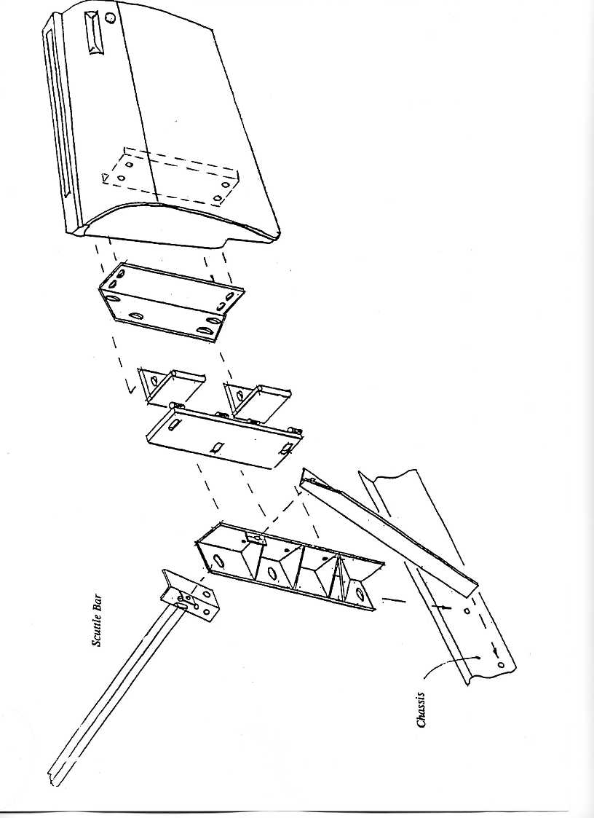

- Page 47 -
ENGINE & GEARBOX INSTALLATION

The Sebring International MXR/TMX model is available with the following engine options:

Rover V8 3.5 Litre – 5.2 Litre - all options in between with 5-speed manual gearbox
Chevrolet 350 Cu In 5.7 Litre - also 383 Cu In stroker engines with 5/ 6 speed
manual gearbox

Fitment of the basic engine units is very similar so all will be dealt with simultaneously with reference made to any specific differences during the description.

All the engine and gearbox combinations are VERY HEAVY so take care when positioning the units in the chassis and do not place fingers, toes or bodies under the engine whilst it is only supported on a crane or lift.

- Page 48 -
FITTING THE MOUNTING HARDWARE

The engine mounting brackets will be supplied for your specific engine choice and all are handed so check the correct unit is fitted to the corresponding side of the engine. Always use shake-proof washers under the heads of the bolts that secure the brackets to the engine block. All engines use rubber mounting isolators from a Rover 3.5 V8 SDI model 1978 to 1982 – except Chevrolet engines which use 1961 to 1963 Corvette mounting rubbers (Part No. MM2285 or Sealed Power Part No. 31-2308.

The gearbox crossmember for each application is designed to bolt to the standard rubber mounting which should be inspected and replaced if not in very good condition. Again use a shake-proof washer under the retaining nut.

The engine and gearbox should be fitted as a unit using a lifting chain or strap and a suitable lifting device which can be hired for the day from most good plant hire shops. Do not be tempted to try and fit the unit into place with a few friends and a length of rope or you will regret the experience for years to come.

- Page 49 -
INSTALLING THE ENGINE/ GEARBOX

With the engine and gearbox suitably suspended, roll the crane towards the chassis and feed the back of the gearbox into the transmission tunnel until the unit is in approximately the correct position.

The back of the gearbox should then be supported with a jack and lifted until the crossmember touches the floorpan. The engine rubber mountings must sit in front of the chassis mounting plates on Rover engine fitments, and behind the mounting plates on the Chevrolet engines and can now be bolted securely to the chassis mounting plates.

The gearbox tailshaft should now be centred in the transmission tunnel from below the car and four pilot holes drilled up through the floorpan using the crossmember as a guide; these holes can then be enlarged from above and the crossmember bolted to the floor using the bolts in the fastener pack – the bolts must be fitted from above the floorpan downwards to avoid deforming the carpet.

Now that the engine/ gearbox is securely bolted to the chassis, the lifting crane can be removed but check that the chassis is still properly supported by the axle stands as you have just added approx. 300 to 400 ponds to the overall weight of the unit.

- Page 50 -
FITTING THE RADIATOR & FRAME

Drawing No. TMX035 shows an exploded view of the radiator frame as seen from the front of the car.

The lower frame bolts to the inside face of the chassis rails and supports the weight of the radiator.
The upper frame is bolted to the two slotted holes on either side of the chassis and can be angled backwards or forwards later to align the bonnet slam panel with the front body clip position. Before resting the radiator in position place a small rubber grommet over each of the locating studs on the bottom face to prevent any chafing between the radiator and the frame. The top slam panel is fitted later as it will foul the body clip when lifting it on and off, but the top edge of the radiator can be secured to the frame temporarily with adhesive tape to hold it still.

The Kenlowe fan unit can now be mounted to the radiator following the instructions supplied with the kit; the thermostatic control switch will mount to the inner wing later.

The radiator hoses can now be connected to the engine with the filling point the highest part of the top hose. The radiator header tank should be fitted to the bulkhead moulding as high as possible without fouling the bonnet line and a length of hose connected from the small outlet at the bottom of the tank to the small hose connection on the side of the filling point.

On SU Carburettored Rover 3.5 V8 engines the small pipe at the front of the inlet manifold just below the carburettor must be connected with a ‘T’ piece between the filler pipe and the header tank as is an air bleed tube and can cause over-heating problems if ignored.

- Page 51 -
Drawing No. TMX035

Radiator frame assembly

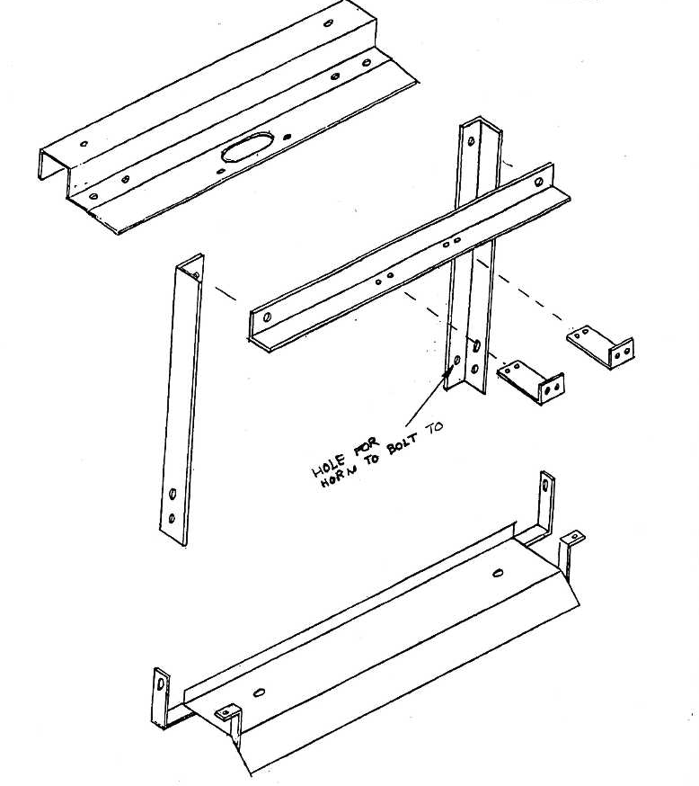

- Page 52 -
FITTING THE STEERING COLUMN & LINKAGE

Measure 168mm from the inside of the angle end of the scuttle bar and drill a 10.5mm hole right through the scuttle bar. Use the steering column mounting bracket as a template to mark the position of the second hole, the column mounting bracket is bolted to the underside of the scuttle bar – See Drawing No. TMX036.

Drawing No. TMX036

Steering column mount/ Scuttle bar brace
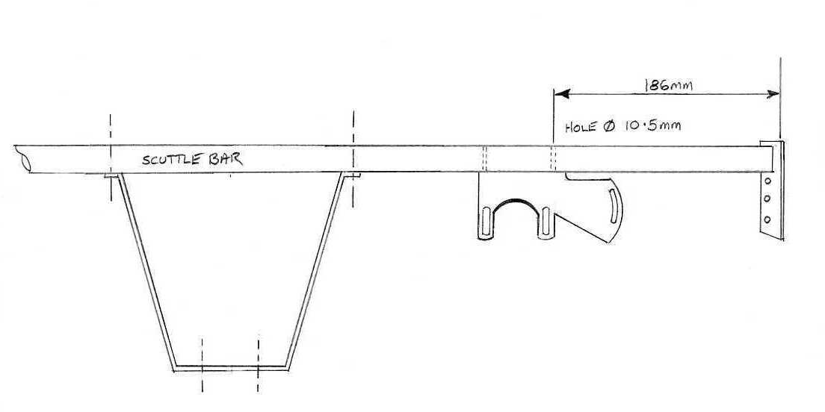
The Ford steering column can now be fitted; fit the Ford bottom bush rubber grommet into the steering hole in the bulkhead, then press the round plastic bush into the grommet. Fit the thin locking washer to the steering column lower shaft and then the remaining plastic bush to the column shaft.

Put the column through the lower bush so that the plastic bush on the column fits firmly into the plastic bush housed in the grommet. The column shaft needs to protrude through the lower bush by 45mm. The column top mounting can be bolted to the mounting bracket with the bolts from the fastener package. Once the column has been set with 45mm protruding, the lock washer can be tapped down the column shaft so that it locks against the plastic bush, thus preventing the bush from moving back up the shaft.
- Page 53 -
The remainder of the steering linkage can now be connected – See Drawing No. TMX037 – the lower steering shaft will require cutting to length; the length required can be determined by fitting the top link support bush and middle U/J - DO NOT over-tighten the plastic support bush.

Drawing No. TMX037

Steering linkage

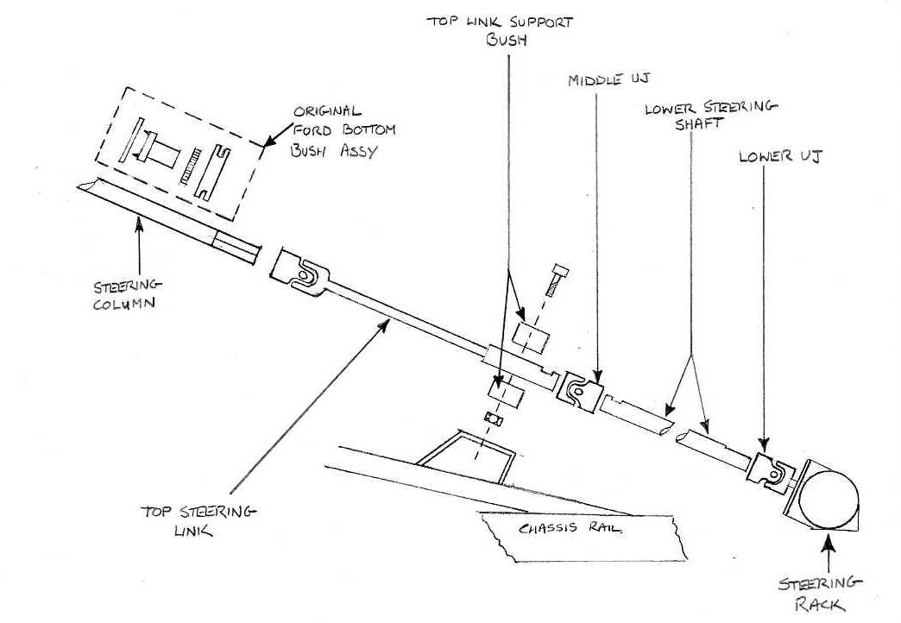

On cars fitted with the a Rover V8 and standard manifolds a heat shield will be required to protect the steering support bush from the manifold – this can easily be made from a piece of 2mm aluminium flat sheet – See Drawing No. TMX038.

- Page 54 -
DRAWING No. TMX038
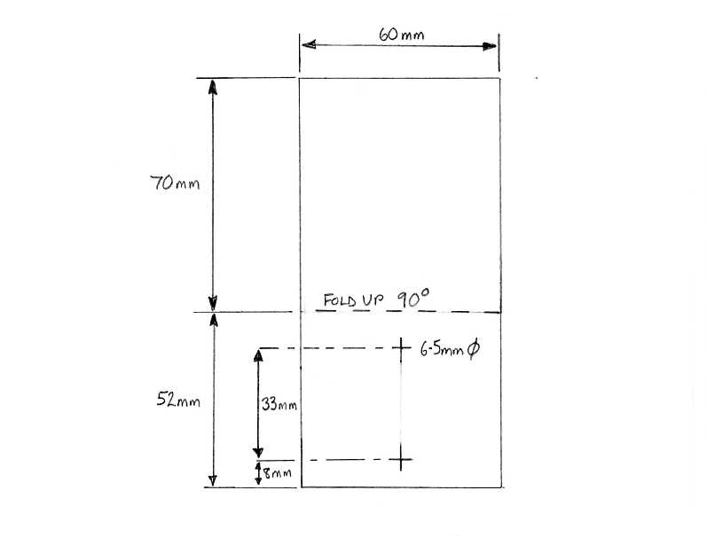

- Page 55 -
BODY PRE-ASSEMBLY & INITIAL PANEL FIT

Before starting any work on fibreglass panels please refer to the safety recommendations at the beginning of this manual regarding dust created by working with GRP, and skin protection.

A good deal of preparation work and fitting of smaller ancillary items can be carried out before the body panels are fitted to the chassis.

A large piece of carpet on the workshop floor will help to protect the gel-coat finish as the body sections are inverted for certain operations and it will also prevent damage if all exposed surfaces are covered with a sheet of foam material held in place with masking tape.

The body shell supplied by Sebring International has a black gel coat finish, the body shell, bonnet, boot, doors and front wheel arches must be painted. However, this can only be done once the body has been fitted.

The body is supplied with the majority of holes already cut-out; the only remaining holes to be cut are for:
Fuel cap
Aerial
Windscreen frame holes
Windscreen washer jet holes
Doorlock/ handle holes
Hood frame mounting holes
Wing beading

- Page 56 -
DRAWING No. TMX039

Dimensions for pre-assembly holes
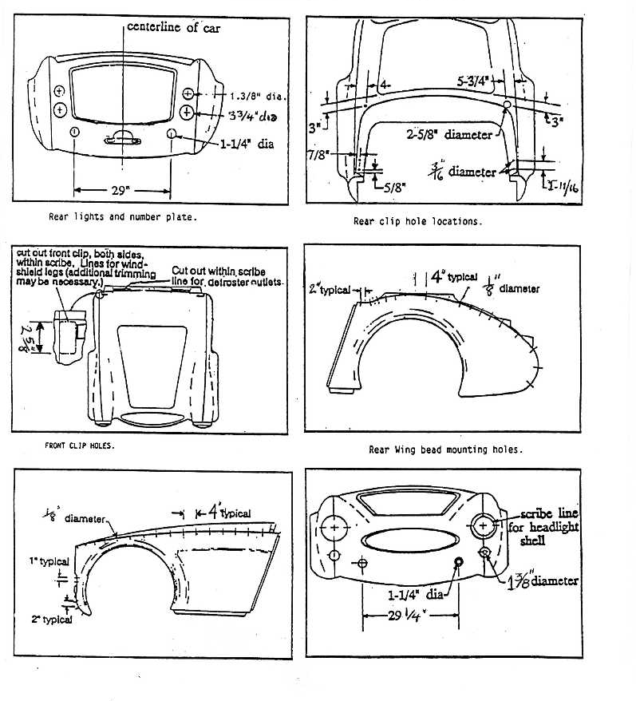

- Page 57 -
REAR CLIP PREPARATION

Drawing TMX039 should be studied carefully as it shows all the hole sizes and positions for the fitting of the front and rear lamps, fuel filler cap and aerial holes and the wing beading hole placement. Use a hole saw or large drill and file to obtain final size on the bigger holes to avoid chipping the gel coat.

After drilling the holes, invert the rear clip to allow the rear bulkhead to be fibre-glassed into place;
fit the rear bulkhead, ensuring that it is central in the rear clip – it can be held in place with a few self-tapping screws through the body return flange into the top edge of the bulkhead. DO NOT FIX the bulkhead to the door aperture returns yet as the lower sections of the clip have to be sprung outwards a little to allow the clip to fit over the rear of the chassis sill section. When the bulkhead is in the correct position it can be bonded into place with strips of fibreglass matting (approx. 3” wide x 12” long) and well mixed fibreglass resin; the rear clip can now be turned right side up and is ready for fitting.

FRONT CLIP PREPARATION

The pre-marked holes for the washer jets can be drilled to size to suit the washer jets, the body may require removal of material from around the washer holes on the inside of the clip to enable the washer jet securing nuts to be tightened. The front grille frame can now be tackled; you will notice that there are 40 dimples pre-marked in the fibreglass surround panel at the top and bottom edges – you have the choice of either a 20 or 40 bar grille so drill the correct number of holes for your application.

DRAWING No. TMX040
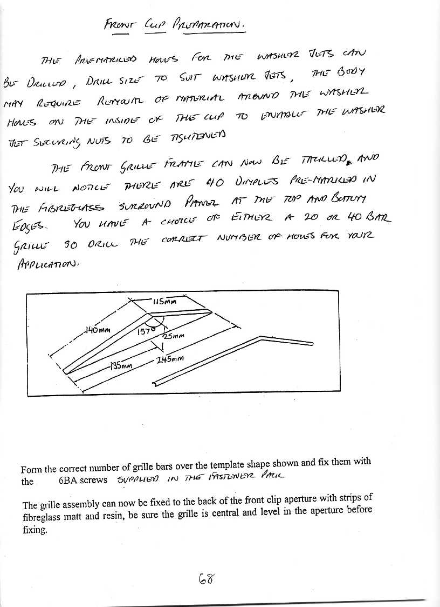
- Page 58 -
Form the correct number of grille bars over the template shape shown in Drawing No. TMX040 and fix them with the 6BA screws supplied in the fastener pack.

The grille assembly can now be fixed to the back of the front clip aperture with strips of fibreglass matting and resin, be sure the grille is central and level in the aperture before fixing.

FITTING BODY PANELS TO CHASSIS

Whilst the front grille is setting, cut two lengths of M12 studding to 8” and two lengths to 4” – these will pass through the bumper extension tubes and secures the front and rear clips in position whilst they are shuffled around to get the door closure lines correct.

The longest tubes fit to the front clip and the shorter tubes to the rear clip.

Using the bumper extension tubes and studding as a location guide, lift the rear body section onto the chassis and push it as far forward as it will go.

The boot floor will be about 1/2" above the chassis and the rear cab liner should be sitting nicely on the floor.

Fit the rear wheels to the axle and use these to centralise the rear body section by ensuring the wheels are central in the wheel arches. DO NOT FIX IT DOWN YET! There is a good deal more shuffling about needed to get the panels to fit exactly, so hold the rear clip in position on the chassis with two ‘G’ clamps on the body return flanges just in front of the rear wheels.

Study Drawing No. TMX034 for the hinge assembly details and then the doors can be offered up to the chassis and held in line with the rear clip using the swage line half way up the door as a reference point for height.

You will need assistance now to mark through the hinge position onto the front face of the door liner where the four fixing bolt holes need to be drilled.

- Page 59 -
The door can now be lifted away and drilled, the securing plate with captive nuts placed inside the door behind the drilled holes and the main hinge plate bolted to the outer face of the door liner.

Bolt the door to the post with two of the four M10 bolts only as it will have to be removed later and this avoids undue effort.

The front clip can now be lifted onto the chassis again using the bumper extension tubes as a fixing at the front and the rear edge of the clip lined up with the doors.

DRAWING No. TMX041
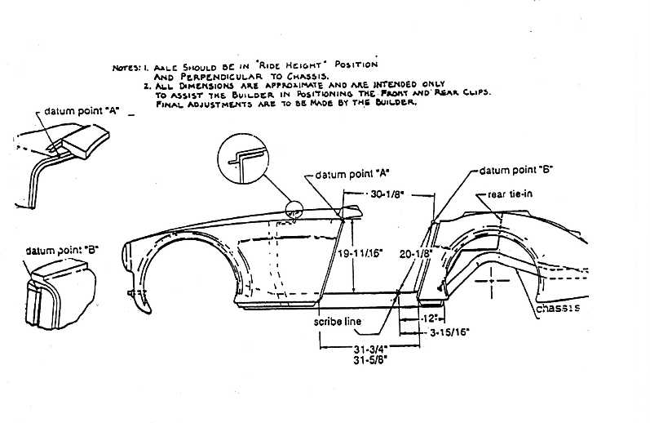
The front clip can be secured by the lower body return flanges like the rear clip whilst the clips are moved around to ensure perfect alignment with the doors.

Aim for an even 1/4” gap at the front and back of the door and ensure that the door is mounted high enough to clear the chassis sill section with the inner liner – remember that a layer of carpet will also be on top of the sill. Study Drawing No.s TMX041 & TMX042 for body alignment measurements.

- Page 60 -
When you are sure that it all lines up properly, drill through the body return flange into the chassis sill section, but be careful and check before you drill that the hole does not coincide with the outrigger panels on the rear of the chassis sill.

DO NOT FIT THE BOLTS YET! Now the holes can act as location points when the front clip is refitted, remove the front clip and drill the top location hole through the door jamb to lock the angle of the door post, tighten all the bolts fully and replace the front clip.

DRAWING No. TMX042

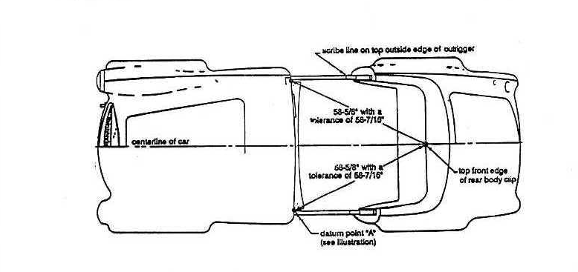
Now both front and rear clips can be bolted on tight, the rear bulkhead can be riveted to the floor and transmission tunnel and the back of the door shut returns can be fibreglassed to the rear bulkhead.

The front bulkhead can be pushed as far forward as it will go at the top edge. Trim the fibreglass bonnet hinge cover mouldings to shape and wedge in place with a spacer from the scuttle bar.

- Page 61 -
FRONT BODY MOUNTING – MXR ONLY

The front body mounting bracket is bolted to the front of the chassis using the slotted holes at the very front of the main chassis rails. Two rubber mountings are supplied which then bolt to the mounting bracket and the body shell behind the recess area for the front number plate. If the holes in the body are countersunk this will enable the number plate to fit flush.

DRAWING No. TMX043
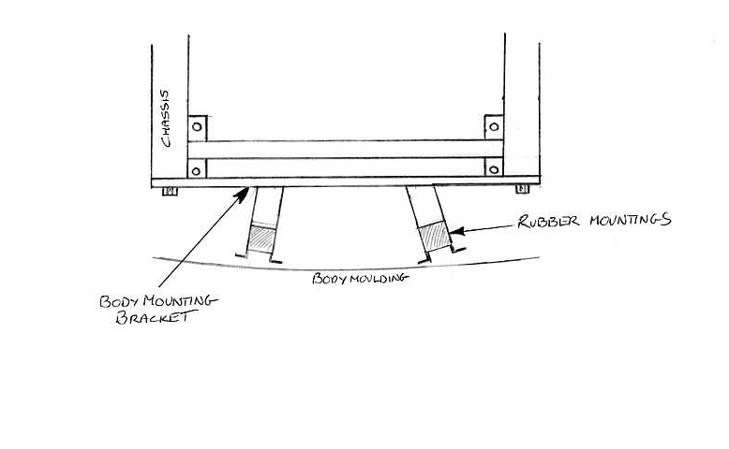

- Page 62 -
FITTING THE WINDSCREEN

The holes in the top edge of the scuttle should be enlarged until the legs of the screen frame pass through without binding and the screen settles down on to the top of the scuttle.

The screen is secured to the scuttle support bar with steel clamping plates, tubular steel spacers, cap head bolts and nylocs – see Drawing No. TMX045.

The scuttle bar can be adjusted on the elongated holes until the screen sits tight up against the raised portion of the scuttle along its lower edge and the measurement from the top corners conforms to the datum measurement in Drawing No. TMX044.

DRAWING No. TMX044
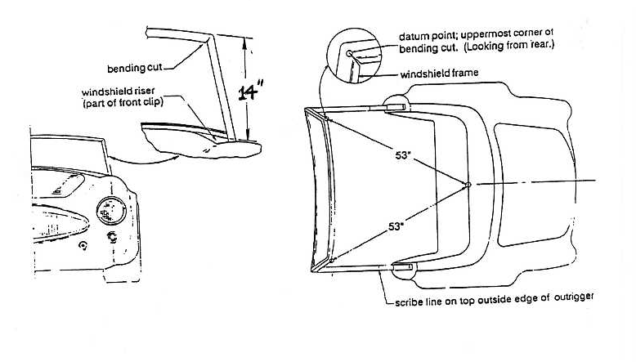
The measurements of the screen position are vital as they determine the fit of the soft top and side windows so take a little extra time and get them as accurate as you can.

Seal the area around the windscreen frame to the body with PU sealer to prevent leaks.

A bead of clear silicone can be squeezed under the lower screen seal to body to prevent water leaks as well.
- Page 63 -
DRAWING No. TMX045
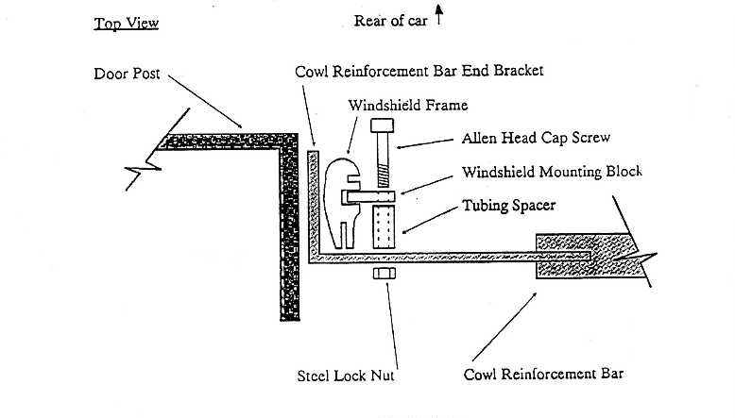

BONNET, HINGES AND FITTINGS

See Drawing No. TMX014 which shows the hinge assembly details.

The bonnet inner panel has a raised ridge around its periphery and slot needs to be cut in the back edge of this ridge on either side in line with the bonnet hinge position to allow the hinge clamp plate to be slid inside the moulding.

Another aperture needs to be cut in the rear face of the bonnet catch mounting area to allow access to the securing bolts for the catch.

Push the rubber seal onto the return flange around the bonnet opening and place the bonnet in position making sure there is an even gap all the way around the edges. While someone else pushes down on the top of the bonnet, reach up from under the front wing and mark the position of both bonnet hinge securing holes onto the underside of the bonnet liner.

- Page 64 -
Lift the bonnet off and drill through the inner liner, slide the clamp plate into the inner liner and thread two pieces of M8 studding into each plate (cut the heads off M8 bolts supplied in the fastener pack).
The bonnet can now be lifted back into position and secured with plain and locking washers and plain nuts.

The rear edge of the bonnet may need to be sanded down to clear the scuttle as it opens to avoid scuffing he body. Adjust the bonnet until the gap is equal around the edge before finally tightening the securing nuts.

FITTING THE BOOT FLOOR SUPPORTS

The boot floor supports are fitted to the outside of the chassis rails, there are two per side; the longest fits to the front of the exhaust mounting welded to the chassis and the shorter one fits to the rear of the exhaust mount. Once fitted to the chassis they can be riveted to the boot floor after drilling from the underside using supports as templates; rivet from inside the boot using large head 3/16” rivets.

FITTING THE BOOT LID

The boot lid comes with the hinge positions marked by four dimples on the outer skin; drill these and attach the hinges. Push the rubber seal onto the flange around the boot opening and rest the boot lid onto the seal. The holes for the securing studs can now be marked on the rear scuttle and drilled through. If the holes in the rear scuttle are elongated slightly it will allow a degree of adjustment.

- Page 65 -
BONDING THE FRONT BULKHEAD

The bulkhead can now be bonded to the body shell using strips of fibreglass matting and a well mixed resin. BEFORE commencing, all surfaces to be bonded should be ‘SCUFFED UP’ using coarse sandpaper. Any components which may be splashed with dripping resin should be covered with newspaper and masking tape (i.e. pedal box, steering column, bonnet hinges etc).
Make sure the curvature of the scuttle panel follows the curvature of the bonnet rear edge – if not the scuttle panel can be raised slightly by packing between scuttle panel and top return flange of front bulkhead. Also if there is a large gap down the sides between the body and bulkhead, these can be packed with cardboard – this will stop the body sides being pulled to the bulkhead during the curing process and causing a ripple effect on the body.

FITTING THE SILL COVER PANELS – TMX ONLY

The moulded fibreglass sill covers should be fitted next ensuring that there is an even gap between the bottom of the closed door and the top of the sill panel.

The cover may need a little filing to get a perfect fit as it is made slightly oversize to accommodate variations in panel fit.

The cover is secured to the chassis sill with three coach bolts through the lower return flange in the same manner as the front and rear body clips and through the step area with three M6 button heads drilled and tapped into the chassis.

Once the cover is secured in position fill any gaps between the cover and the front and rear clips with PU sealer to give a neat finish and prevent water ingress.

Two lengths of ‘L’ section plastic trim are available to cover the lower return flanges of the body clips and coach bolt heads that secure them. They are held in place with self-tapping screws along the bottom face of the body clips and sill covers, ensure they are straight as you screw them on and trim any surplus from the ends with a pair of tin snips afterwards.
- Page 66 -
FITTING THE FULL-LENGTH SILLS – MXR ONLY

A small amount of extra trimming will be required to enable a good fit to the body. The sill can be clamped into place with a G-clamp along the main chassis sill in the door aperture. The ends of the sill are secured to the body by using 3/16” rivets (preferably peel-back type). Drill through from inside the wheelarch and before riveting into place a small amount of PU sealer should be put on the area where the sill meets the body.

The centre section of the sill in the door aperture can be fixed to the chassis sill by drilling a 5mm hole and tapping out to 6mm; three screws in each sill is sufficient. Remember that the sill carpet will need to be tucked down between the chassis sill and sill moulding.

If you wish you can make the sills look an integral part of the car by filling along the joint where the sill meets the body. DO NOT use ordinary body filler as it will crack, instead use a semi-rigid adhesive which you can sand down, such as U-POL 902.

- Page 67 -
FITTING THE SIDE REPEATER LAMPS

See Drawing No. TMX046 for the side repeater lamp positions. The hole size and layout will depend on the type of lamp used. Once the lamp has been fitted a wiring loom will need to be made for each lamp – a length of 2-core insulated wire is ideal. Connect to the side repeater wire in dash loom and connect an earth wire to the scuttle bar – the bolts that hold the scuttle bar brace in position are suitable for this.

DRAWING No. TMX046
Side repeater lamp position

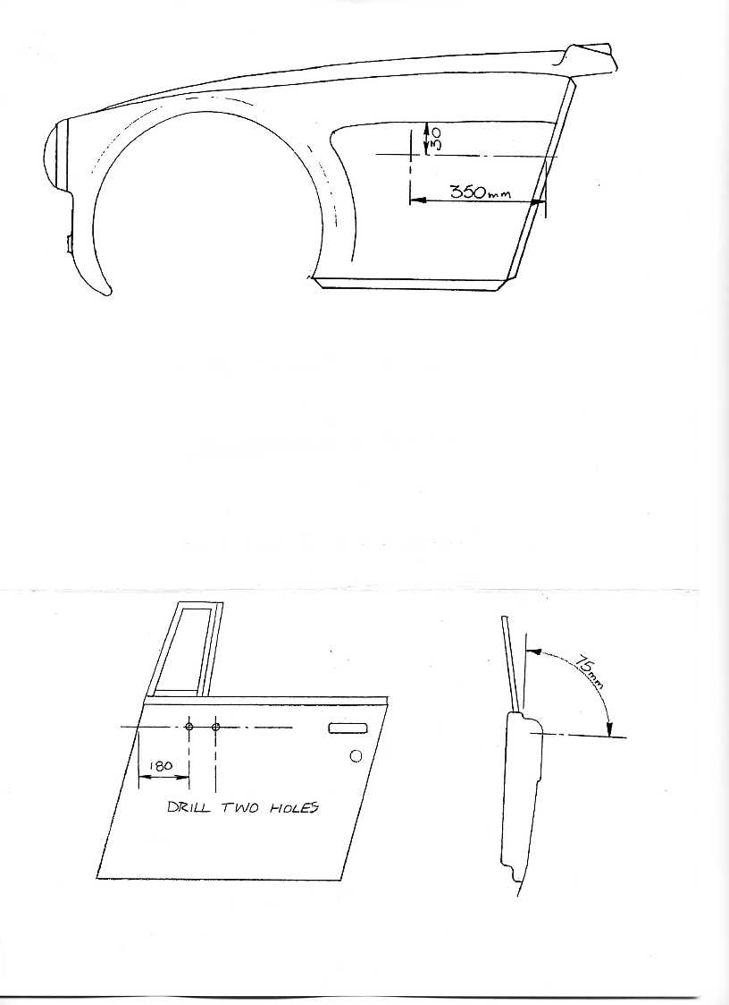
Door mirror position

- Page 68 -
FITTING THE DOOR MIRRORS

The door mirrors supplied by Sebring International are mounted onto the doors at the positions shown on Drawing No. TMX046. Any deviation from this position may result in an SVA failure.
Follow the instructions supplied with the mirrors for fitting.

FITTING THE SCREEN PILLAR TRIMS

The windscreen pillar trims comprise of the three components shown in Drawing No TMX047.
DRAWING No. TMX047
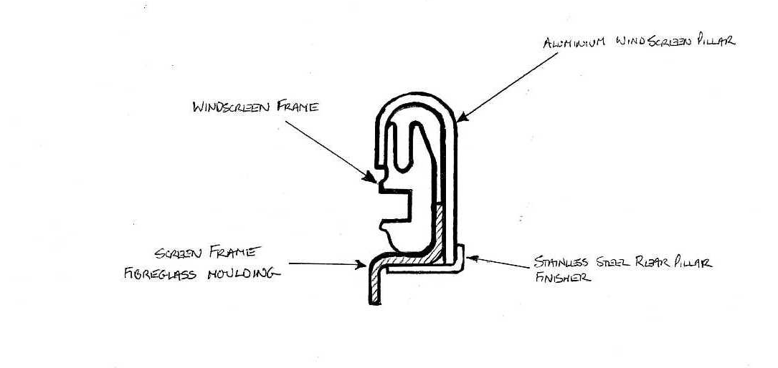
The backing plate is a fibreglass moulding, the inside face of which will be visible when the assembly is complete – so it is advisable that the moulding be trimmed with leather/ vinyl AFTER it has been pre-fitted; the inside face is opposite to the gel finish.

Trim the bottom of the moulding till it fits neatly to the body at the rear of the windscreen frame, then trim the top off the moulding at 90 degrees to the frame; the moulding is secured to the windscreen frame with two short self-tapping screws. Drill the holes in the two recessed areas in the moulding and into the windscreen frame – be very careful whilst drilling these holes as the screen glass is on the other side. Aim for a parallel gap of approx. 10 to 12mm between the moulding and the front edge of the quarterlight.
- Page 69 -
The aluminium trims will require trimming to fit; a small amount of trimming is needed to enable the trims to slot over the windscreen frame at the top. The bottom will need material removed to fit the body – also the inside rear edge may need trimming to allow the pillar to be fitted in its ideal position, which is with the rear outer edge following the line of the fibreglass moulding. A very sharp pair of tin snips will be required and a good file for cleaning up the edges afterwards. Take your time – a good finish is essential as the trims are a very visible part of the finished car.
Allow a small gap between the bottom of the trim and body to allow the seal supplied in the glazing kit to be fitted.

Once you are happy with the trim it can be fitted to the windscreen pillar on the inside using two No. 4 countersunk self-tapping screws and surface cup washers.

Drill and fit one in the centre and one at the lower end of the trims – DO NOT fit to the top as the hood fixing studs will secure the trims at the top. Also make sure that where you drill through you are actually drilling through the windscreen frame as well.

The rear finisher trim can now be fitted, the length will need to be finalised by removing material from the bottom. It is fixed to the fibreglass moulding by three 1/8” by 1/2” rivets. Where the finisher overlaps the pillar on the outside secure this by riveting with four 2.4mm x 5mm rivets.

- Page 70 -
FITTING THE SPEEDO SENSOR

The Speedo sensor is fitted to the offside diff mounting via a small bolt-on angled bracket – See Drawing No. TMX048 showing the positions for drilling the angled bracket mounting holes in the main diff mounting.

Bolt the bracket to the inside of the main diff mounting with the angle towards the diff. The 4-pole chopper plate is bolted between the diff flange and propshaft. The sensor should be adjusted so that the gap between it and the chopper plate is a minimum of 0.5mm to maximum 2.0mm.

Run the wiring from the sensor inside the car along the bottom of the transmission tunnel on the passenger’s side. Drill a small hole at the rear of the tunnel to allow sensor wire into the car, use a grommet to prevent the wire from chafing through. The wiring diagram on page ??? shows details of the Speedo wiring.

DRAWING No. TMX048
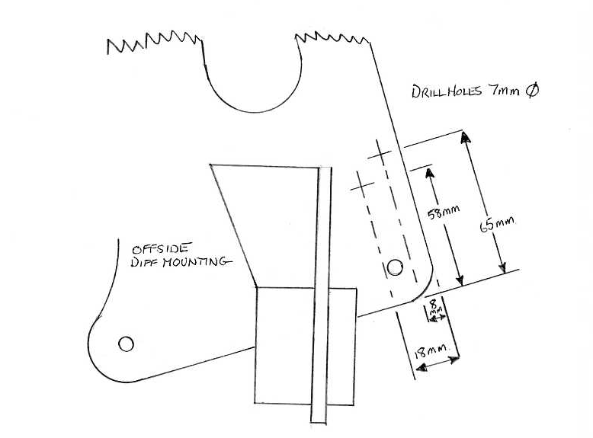

- Page 71 -
FITTING THE WING BEADING – TMX ONLY

The ends of the wing beading need to be formed to give a neat finish at the cut ends and this is achieved by bending the end over at an angle of approx. 45 degrees and hack-sawing across the bend in line with the bottom edge of the beading.

DRAWING No. TMX049
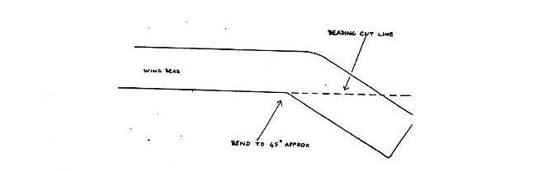

A hardwood block with a 5/16” hole drilled in it will hold the end nicely without damaging the face of the beading whilst it is bent over and shaped. Finish the shape off with a file afterwards to achieve a neat result.

The beading is held to the body with 6BA screws and nuts; the head of the screw fits inside the beading and after the nut is wound onto the screw from inside the body panel the end of the screw can be gripped with a pair of pliers to stop it turning whilst the nut is fully tightened.

The beading on the tops of the front wings will need cutting off just in front of the windscreen pillar.

- Page 72 -
DOOR LOCKS & LATCHES

The doors ARE THE MOST COMPLEX part of the Sebring International cars build and you will need to be in a good and patient state of mind to complete this section well as it involves a good deal of detail and finishing work.

Start by cutting out the scribed area on the rear face of the door liner for the door latch assembly.

Secure the latch assembly to the door with the three countersunk screws in the fastener pack – use the template at the rear of the manual for the cut-out and hole positions.

Drill out the two 5mm holes for the outer door handle.

Carefully drill out the elongated hole for the door release lever which protrudes from the back of the exterior door handle and clean up the edges with a file.

Fit the handle to the door with the screws and washers supplied in the fastener pack.

Next cut the hole for the door lock barrel. Do not cut a round hole as the indents around the edge are to stop the barrel rotating as the key lock is operated – so file carefully to shape until the barrel is a snug fit and the key slot is exactly upright.

The lock barrel is retained by a spring blade clip that was originally designed to secure the unit to a thin steel panel, and accordingly the slot into which the spring fits is in the wrong place. The simple remedy for this is to cut another slot approx. 1/8” further back than the original with a hacksaw. As long as the blade is held square, the cut is the right width and will allow the clip to slip in.

The plastic tab on the lock assembly faces to the rear and slightly upwards in both doors.

The internal door lock fits into the recess moulded into the door liner and only the shallow section needs to be cut-out.

- Page 73 -
The door lock is fastened to the door by drilling out the hole in the middle of the moulded recess and screwing the lock into position using a countersunk screw and nut. A pre-formed clip supplied by Sebring International slots onto the rear of the lock and is screwed to the door with self-tapping screws.

Now that all the operating handles are in position the locking rods can be made, it is best to re-use the existing rods from the donor vehicle as they can be cut to length and they have one end already formed.

The yellow plastic clips secure the rod into the elongated holes and the round rubber grommets are fitted to the round holes.

The two operating levers on the top of the lock assembly are for the exterior door handle and the key lock, whilst the two levers on the side of the lock are for the interior handle/ security lock.

Insert the striker pin into the lock and push it home fully to simulate the door in the fully closed position; then close the door and with a pencil mark the position of the plate into the door shut.
Stick masking tape to the door shut first – this will make it easier to mark.

Open the door again and use the pencil marks to drill the holes for the striker pin in the correct position. The holes should be drilled large enough to allow the lock to be adjusted approx. 3/16” in any direction.

The striker pin is secured with the countersunk bolts to the pre-drilled plate fitted to the back of the door shut and can be shimmed out if needed to ensure the lock operates smoothly.

Work the lock by hand until you are familiar with the action of the two sets of levers, then cut and form the operating rods to shape, allowing enough spare rod to insert the operating rod into the latch unit and mark where the second bend will be required then remove the rod.

Using a vice and a small hammer a double bend like the original pre-fold Ford end can be easily achieved.

- Page 74 -
Remember the rods will need to clear items such as the rear window runner, so it is advised that rods from the door lock and handle follow the line of the rear door moulding to the latch and rods from the latch to the internal lock are kept as close to door inner as possible. This is very important if you are fitting electric windows.

To fit the rods from the latch unit to the internal lock once they have been made you will need to remove both the lock and latch from the door; assemble the rods and replace them back into the door as one unit.

- Page 75 -
FITTING THE DOOR GLASS & HARDWARE – MANUAL WINDOWS

Drawing No. TMX052 shows an exploded view of the door glass assembly and should be studied carefully before starting.

DRAWING No. TMX050

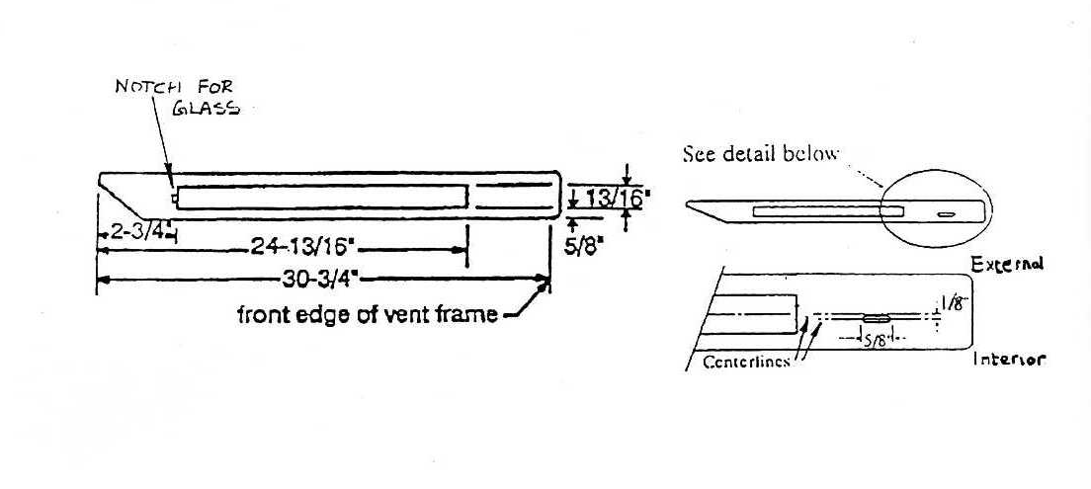
Drawing No. TMX050 shows the assembly details of the quarterlight frame and glass. The angle cut at the bottom should be cut first – this allows the bottom of the window runner to sit closer to the outer door skin.

A 6mm hole should be drilled in the bottom of both runners as indicated and the rear runner should be cut and drilled in a similar manner but opposite handed.

Assemble the quarterlight frame without the glass to start with and drill the holes for the pop rivets.
Now cut the felt lined window channel to size and push into position in the quarterlight frame; then push in the glass, fit the lower part of the frame and rivet through the two holes previously drilled.

When both windows are complete put them aside and study Drawing No. TMX052.

The holes to be cut in the top of the doors have to be cut out accurately as it will affect the way the windows slide up and down. The measurements for the cut-outs are shown above, make sure you note which is the front and which is the back of the door.
- Page 76 -
Drill one 8mm pilot hole in each corner of the section to be removed then, with a metal cutting blade in a jigsaw, join up the holes to remove the centre section. After the door apertures are cut, file them to a good clean edge.

Cut the felt window channel to the correct length and stick it into the main window channel with Sikaflex adhesive. Stick the felt channel into the rear window runners at the same time, they will be trimmed to length later but it avoids having to wait for the adhesive to dry again.

When the adhesive is set, slide the quarterlight assembly down into the door and mark the position of the securing bolt into the top of the door. Drill one 8mm hole in the position shown in Drawing No. TMX050 and extend it into a slot.

Tighten the securing bolt finger tight only for now as the lower window channel securing bolt will push the bottom of the frame out towards the door skin, preventing the lower rail of the quarterlight from sitting square on the top of the door.

Key to Drawing No. TMX051
No. | Description | Quantity per door
1 | Door moulding | 1
2 | Window regulator | 1
3 | Window lower channel | 1
4 | Quarterlight frame | 1
5 | Quarterlight frame lower channel | 1
6 | Window rear runner | 1
7 | Door glass | 1
8 | Quarterlight glass | 1
9 | Aluminium extrusion | 2
10 | Window glass wipes | 2
11 | Window felt | 2.5 metres
12 | Window winder handle | 1
13 | Screws - 10 per runner | 2
14 | Washers - 10 per runner | 2
15 | M6 bolts – Regulator | 4
16 | M6 washers – Regulator | 4
17 | Door panel screws | 9
18 | End finisher plate | 1
19 | Screws - door wipes to alloy extrusion | 10
20 | Washer - quarterlight lower channel | 1
21 | Nut - quarterlight lower channel | 1
22 | M6 studding - front & rear runners to door | 2
23 | Rivet - quarterlight bottom channel | 3

- Page 77 -
Drawing No. TMX051

Door assembly
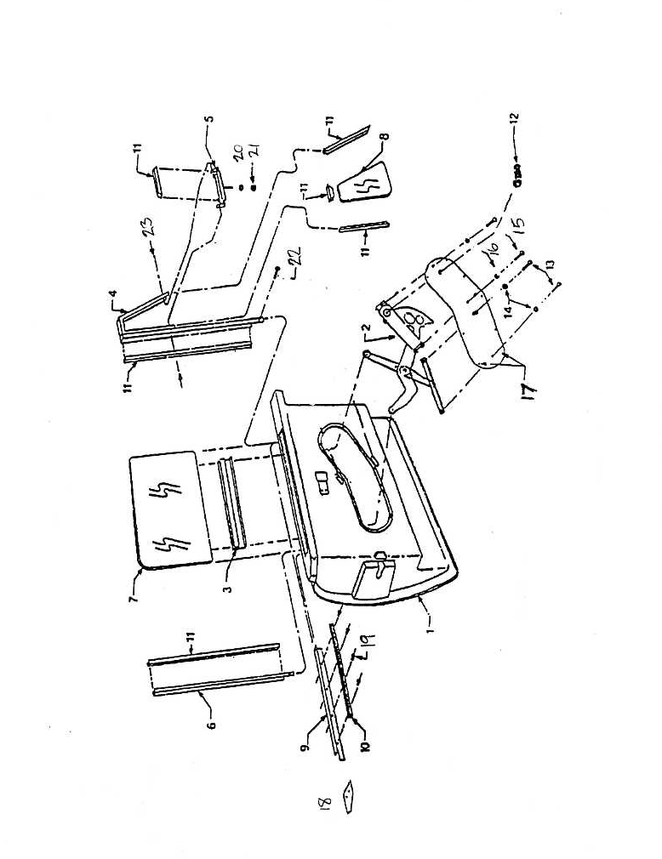

- Page 78 –
Drawing No. TMX052

Side window assembly
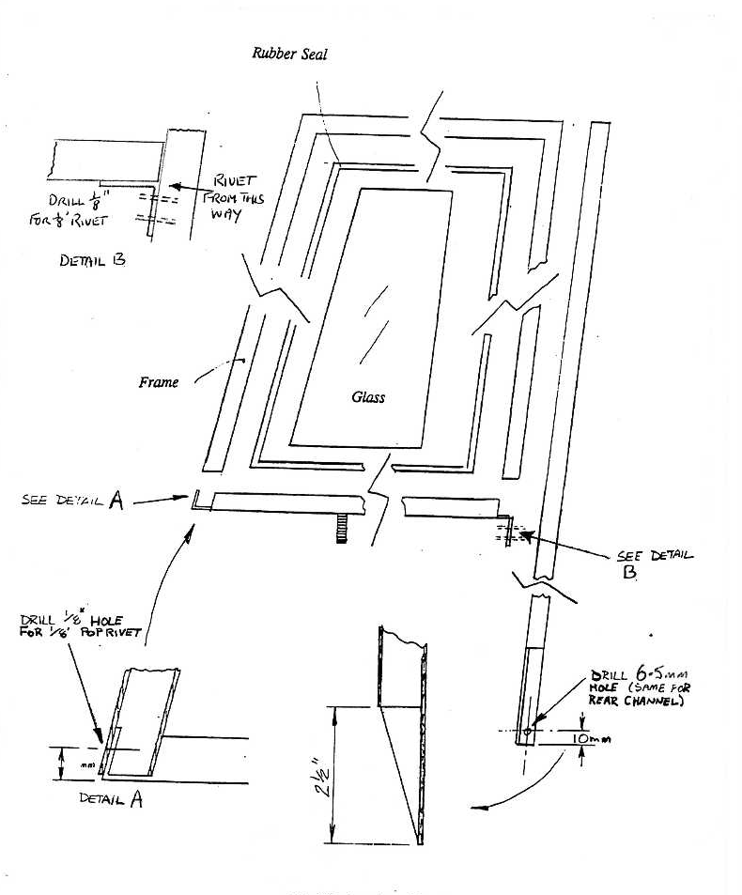

- Page 79 -
Drawing No. TMX051 shows how the lower window runner securing bolts are assembled, the positioning of the holes in the door liner involves a little guestimating but as you are fitting a large repair washer either side of the door liner the hole can be elongated to line up with the bottom runner exactly.

Drawing No. TMX053

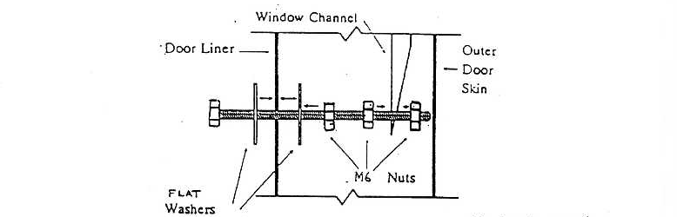

Using a long straight edge, extend the position of the window runner down the inside of the door liner and mark a line where the runner should be, then mark down approx. 3/4” from the bottom edge of the door return and this should be the approximate position of the lower securing bolt.
Once you have drilled the hole the bolt can be inserted and by looking inside the door you can see how much the hole needs filing to align properly.

The securing bolts can now be assembled in the front runners, the lower edge of the runner should be approx. 1/4” from the outer door skin when tightened.

Drawing No. TMX054

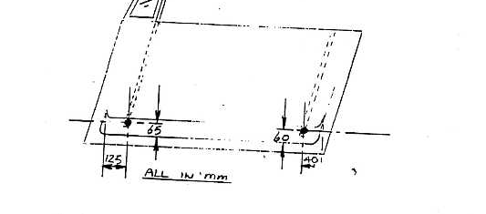
- Page 80 -
The window winder channel that fixes to the bottom of the glass is an aluminium extrusion with a flat rubber insert pushed into the upper channel to grip the window firmly. Remove the rubber channel and coat both sides with washing up liquid, or something similar to act as a lubricant whilst the channel is installed onto the glass.

The window channel can now be pushed onto the window whilst holding the rubber insert onto the glass. You will need to push very hard until the channel sits fully onto the window glass. This is easier to achieve by putting a piece of carpet on the bench and standing the window glass up on its edge while you push the channel down.

If the channel needs a little help to seat properly you can tap it gently with a hide hammer, BUT BE CAREFUL not to deform the ‘U’ channel runner or the window mechanism will jam.

File a small notch in the centre of the rear edge of the door top cut-out the same width as the glass.
This is to allow the back edge of the window to sit in this notch while the front edge of the glass is fitted into the runner and slid down the first part until the glass sits fully in the front runner.

The door top cut-out diagram will clarify the position of the notch to be filled. Hold the glass about halfway down into the door and place a wooden block under it to stop it falling down to the bottom of the door. Now slide the rear window runner down into the door, engaging it on the glass on its way down. Mark the lower securing bolt position in the same manner as the front runner.

Adjust the rear runner lower securing bolt until the window is a firm fit in the runners and will slide fully up and down without binding. If the window is too tight in the runners, remove the rear runner and file the door cut out a little longer at the rear edge. Be careful not to extend the hole too much or the window will become sloppy.

When you are happy with the window movement, mark the rear window channel level with the top of the door, remove the channel and cut the excess material off.

Re-fit the channel and adjust the lower bolt to achieve the same smooth movement as before.
The top of the rear channel is covered by a laser cut trim piece, secured by two small pop rivets.
- Page 81 -
The window glass should be held up whilst the position of the trim is confirmed to ensure that it has an even gap on both sides of the glass.

The window winder mechanism can now be engaged onto the glass channel and bolted to the back of the metal insert supplied, and this in turn fixed in the door liner aperture with self-tapping screws.

The secondary winder channel that bolts to the back of the metal insert should be left slightly loose until the window has been fully wound up and down. This allows the channel to centralise itself and can then be tightened fully.

Cut two lengths of ‘L’ section alloy and trim to length to fit between the rear channel cover trim and the quarterlight frame. Be as accurate as possible with the finish of these pieces as they will be conspicuous if rushed.

When the trim pieces are correctly shaped the window side wipe felt pieces can be cut to length and fixed to the inner face of the trim with the self-tapping screws provided. Once the two pieces are screwed together sand off the protruding ends of the screws with an electric sander – this will allow the trim pieces with side wipes to fit easily to the door top and they can now be fixed with four rivets per strip.

FITTING THE DOOR TOP FINISHERS – STAINLESS STEEL TYPE

With this type of finisher plate, you will see that the tops of the doors are rebated; this is to allow the aluminium strips onto which the glass felt wipes are fixed to sit lower on the door top so that the stainless steel finishers can sit flat.

Blunt any edges first and trial fit – a small amount filing may be required to get a perfect fit – use a small amount of PU sealer to bond the finishers to the door and hold in place with masking tape until dry.

- Page 82 -
FITTING THE DOOR GLASS & HARDWARE – ELECTRIC WINDOWS

The side window frames supplied are a one-piece unit with both front and rear runners joined across the bottom by an angled bar; assemble the quarterlight and fit the felt seals to the frame as described in the previous chapter for manual windows.

Fit the side window glass in the front and rear runners, holding the lower channel onto the glass and mark the channel and glass with a marker pen, in the central position. Remove the glass from the frame, invert it and fit rubber seal and channel to the glass using a soft mallet – make sure that the marks are aligned - use insulating tape to hold rubber in place and silicon spray or washing up liquid to ease the channel onto the glass; cut-off excess rubber with a sharp knife.

Re-fit glass to the side window frame and install it into the door through the top aperture. Mark and drill slot for front stud fixing on quarterlight lower channel, secure frame in position with nut and washer on front stud; drill out rear fixing on top of door through the tab on the top of the rear runner.

The bottom of the side window frame is held by two lengths of studding, nuts and washers. There are two recesses in the door at the bottom – these should be drilled out to 7mm. Drawing No. SX054 shows the layout of the studding, nuts and washers – the frame should be kept as near to the door outer skin as possible, but also check the quarterlight frame alignment with the rear of the windscreen frame where the seal runs.

The motor and mechanism can now be installed. The motor goes to the front of the door with the operating cable exit to the bottom, slide the nylon runners into the channel on the bottom of the glass.

The mounting frame for the mechanism can now be fitted; it is fixed to the side window frame by three 28mm spacers, two M6 bolts front and rear and a bolt and nut at the bottom – See Drawing No. TMX056. The mechanism can now be fitted to the mounting frame; the window motor is bolted at the front and the mechanism in the centre. The idler arm can now be fitted to the remaining nylon runner and loosely bolted to the frame – Drawing No. TMX056 shows the position of all spacers and bolts.
- Page 83 -
Drawing No. TMX055

Side window frame lower mounting – electric windows
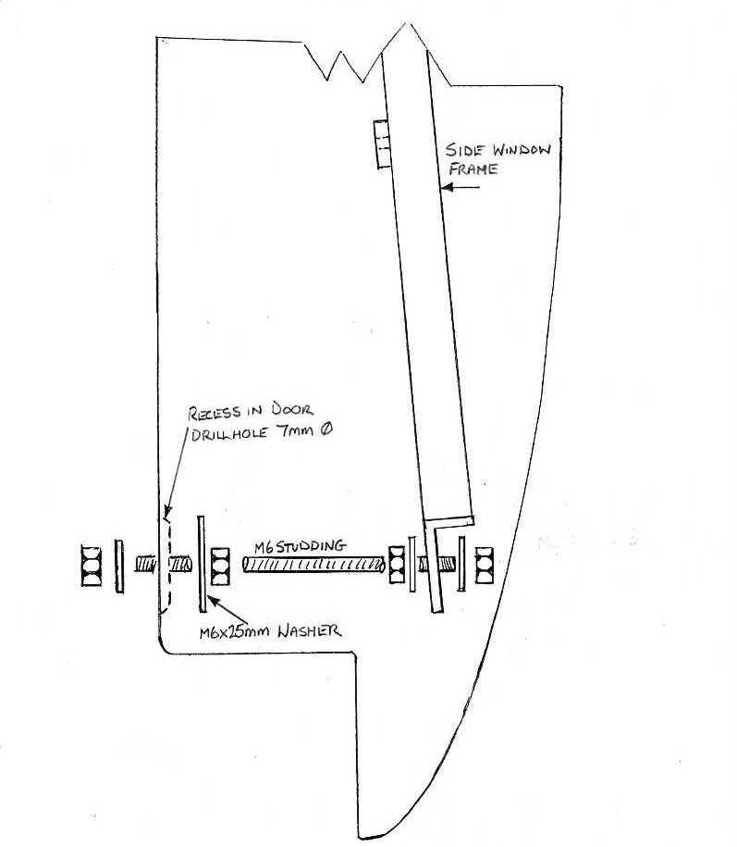

- Page 84 -
Drawing No. TMX056

Electric window mounting
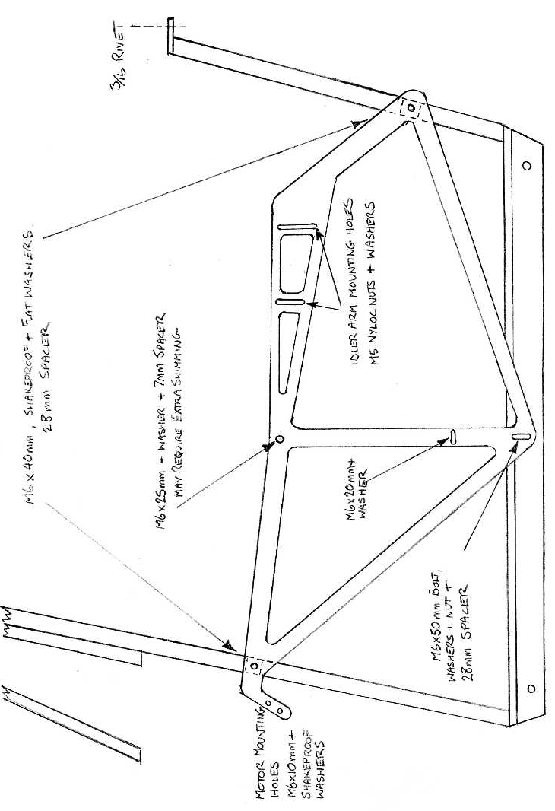
- Page 85 -
To test and adjust the window, connect a window switch to a battery and to the motor; check the movement of the window and adjust the idler arm until you are satisfied. The mechanism may require shimming with washers at its centre top mounting to achieve a smooth action. Once you are happy with the action of the window the motor can be attached to the window switch loom; run the wiring round the back of the doorpost and into the door below the hinge mounting hardware.
Finally, the door cover plate can be drilled and fitted with self-tapping screws.

FITTING THE DOOR SWITCHES FOR ALARMS & INTERIOR LIGHTS

The door switches are fitted to bottom of the doors at the front. An earth return wire will be required and can be connected to the screw and nut holding the switch in place and then earthed on the scuttle bar – See Drawing No. TMX057.

Drawing No. TMX057

Position of the door switch
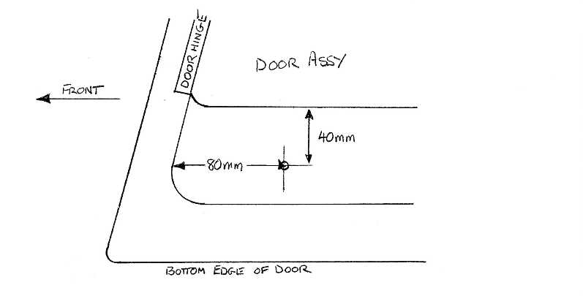

- Page 86 -
FITTING THE DOOR SEALS

The door seal supplied for the quarterlight to windscreen pillar and front door edge are the same; cut them to length and simply push them on. The front body clip flange onto which the lower seal is pushed may require its thickness reduced to 3mm to allow the seal to fit correctly.

Where the two seals meet at the top of the door bond them together with PU sealer to stop water ingress. The door rear and lower edge seal is self-adhesive and is fitted to the body and along the sill panel.

FITTING THE BOOT LOCK & CATCH

The boot lock position is pre-marked on the boot lid; open the hole out to 21mm on both inner and outer skins. Insert the boot lock and lock it in place with the larger of the two collars supplied.
The smaller collar locks the boot lock inner shaft in place – See Drawing No. TMX058.

Fit the boot lock latch to the shaft, lower the boot lid to its closed position and mark the body directly below the centre of the boot lock. Open the boot lid, the boot catch is fitted to the boot seal flange by two countersunk screws and nuts – adjustment can be made by moving the position of the latch on the boot lock shaft.

Drawing No. TMX058
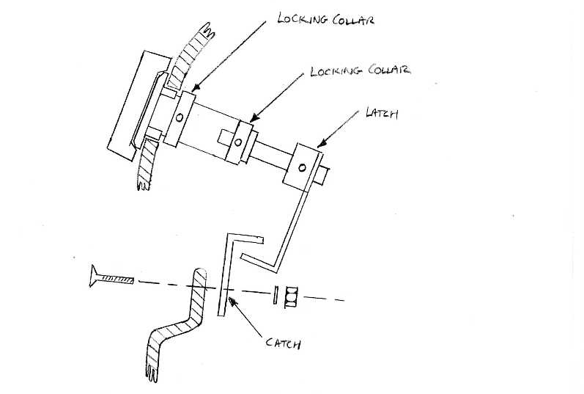
- Page 87 -
FITTING THE FUEL FILLER CAP AND FILLER PIPE - AIRCRAFT TYPE

See Drawing No. TMX039 which shows the centre hole position for the fuel cap. Use An 82mm hole saw to cut-out the hole; using the fuel cap as a template, mark and drill the fuel cap fitting holes. Once all holes have been made, fit the cap to the bodywork with the cork gasket between the body and filler cap.

The filler cap funnel is fitted to the underside of the body. Some cleaning up of the area (especially where the boot liner is bonded to the body) may be required, use another cork gasket between the funnel and body; use the screws and nuts provided in the fastener pack to secure the cap and funnel.

The filler pipe can now be fitted; cut the large diameter (2”) fuel pipe in half and using the hose clips provided, fit filler pipe with breather pipe towards the top. Finally connect the breather pipe.

FITTING THE FUEL FILLER CAP – CHROME LOCKING TYPE

The fuel filler cap is fitted in the nearside rear wing and is held in place by the rubber grommet which fits around the pipe and sits either side of the fibreglass panel. Due to the thickness of the fibreglass you will need to taper the bottom face of the panel to allow the grommet to sit properly – See Drawing No. TMX059.

Drawing No. TMX059

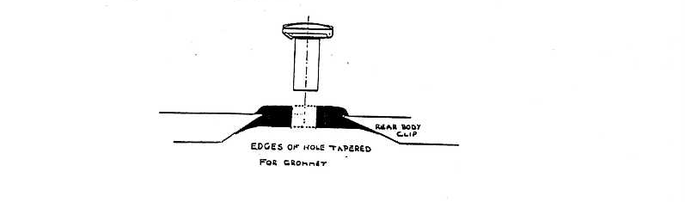

- Page 88 -
FITTING THE EXHAUST SYSTEM

The exhaust system supplied by Sebring for the TMX/ MXR is made from stainless steel, the only difference between the systems is the design of the tailpipe, and is a straight forward bolt-on system.

Start with the front down pipes and work backwards. The centre boxes also include the over axle pipes as part of their structure. They are fixed to the chassis by two rubber mountings – the mounting points are where the diff carrier meets the rear of the floorpan. The rear boxes can then be fitted; these are held to the chassis by two rubber mountings at the rear.

Use exhaust clamps supplied to clamp pipes and it is advisable to use an exhaust assembly paste at all the pipe joins.

GEAR LEVER POSITIONING

The Sebring International chassis is supplied without the gear lever hole due to the many engine/ gearbox combinations.

Once the engine and gearbox have been fitted and with the vehicle on stands, from underneath drill a small hole either side of the gearlever position. From above, using the stainless steel finishing/ gaiter plate as a template, mark out the hole position to be cut. If a 100mm holesaw is available cut-out the hole using lots of cutting fluid – if not drill two holes and use a jigsaw.

REMEMBER to cover the gearlever hole in the gearbox with a cloth to prevent any metal swarf from entering the gearbox.

- Page 89 -
FITTING THE CARPET UNDERLAY

The underlay is supplied on a roll and will require cutting to shape and size, gluing into place – use a good quality carpet fitter’s aerosol or brush on glue.

Start with the bulkhead area first and cover across the whole area, trimming around any pre-cut holes as you go. Cover below the pedal box and steering column only; then along the top and sides of the transmission tunnel back to the rear bulkhead.

Now cover the rear bulkhead cutting around the seat-belt post covers and back as far as the rear bulkhead upright panel covering the floor only. You should now cover both drivers and passenger’s floor covering to the edge of the sill only – DO NOT COVER THE SILL.

The underlay is now complete and ready for fitting the carpet.

FITTING THE ABS DEMISTER PLENUMS

The demister plenums are fitted to the underside of the scuttle panel; fit the plenums centrally over the pre-cut hole, drill a hole at both ends and rivet into position; seal around the edges with PU sealer. The plenum with the offset hole fits on the passenger side.

- Page 90 -
FITTING THE HEATER ASSEMBLY – FORD ESCORT/ ORION TYPE

BEFORE commencing with fitting the heater assembly, firstly make sure that the donor heater is in good working order.

With the heater outlets facing towards you, fit the large air box supplied to the top of the heater with the M8 bolts, nuts and washers also supplied with the two inlets on the air box to the left-hand side.
A small amount of trimming of the plastic from the heater may be necessary to allow the nuts and washers to seat correctly.

The heater blower motor can now be installed into the air box and the wiring passed through the hole in the air box back panel; seal the hole off with PU sealer. Bolt the blower motor down through air box ad heater with M8 bolts, nuts and washers. Smear a small amount of silicone sealer around the lip of the air box and screw down the lid with self-tapping screws provided.

There are two blanking plates provided in the kit – these are fitted to the two outlets on the heater that originally supplied the dash vents; seal these off with PU sealer. The heater assembly is now ready to install into the car.

To fit heater assembly into the car the transmission tunnel must first be under-laid. Place the heater onto the tunnel and push it forward, mark where the water pipes go through the bulkhead and cut the necessary slot to allow pipes to fit; only cut enough to allow pipes to fit making sure the bulkhead pipe cover will seal around the slot. Push as far forward as possible making sure that there is no contact with the bulkhead, the front face of the air box should be approximately parallel to the bulkhead.

To hold heater assembly in place fold a piece of flat steel plate 60mm down from the end (use the one with the single drilled hole) into an ‘L’ shape, fit brackets to GRP box approx. 20mm in from the side using four of the rivets supplied – drill the holes in the GRP box where required. Once the heater is in the correct position and the brackets are folded up to fit under the scuttle bar, drill 6.5mm hole and bolt it into place with M6 x 50mm bolts supplied – trim off any excess thread and use for earth connections. Some bending of the brackets may be required to suit.

- Page 91 -
Connect the air inlet piping between the bulkhead double connector plate and airbox; on the engine side of the bulkhead fit pipes from double connector plate and fit in between body and metal sill.

Route a small duct hose down from the demisters, fit Ford demister hoses to heater, place reducers in the other end and connect to the duct hose - you may have to reduce the length of the Ford pipe.
When you are happy with the fit, smear a small amount of PU sealer around the reducers where they fit into the Ford pipe.

Upon fitting the centre console the centre vent tube supplied may require shortening, cut the two single pipe ends only to the ends of the corrugated section of the tube.

FITTING THE HEATER ASSEMBLY – SEBRING INTERNATIONAL TYPE

The Sebring heater is supplied with mounting brackets and bolts to the scuttle bar and the top of the transmission tunnel. The transmission tunnel and the bulkhead should have been fitted with the underlay prior to fitting the heater assembly.

Place the heater on the tunnel and mark the bulkhead for the water pipes; cut the water pipe holes through the bulkhead with a holesaw. The water pipe plate can now be drilled and riveted to the bulkhead.

The heater is supplied with two 90 degree brackets; fit these by removing the two screws in the centre of the heater panel (one at a time) and fitting the 90 degree brackets, re-use the screws you have taken out. The brackets are bolted to the underside of the scuttle bar, mark and drill right through the bar. The heater can then be bolted to the transmission tunnel through the bottom feet – See Drawing No. TMX060.

Connect the air hoses to the inlet plate on the left-hand side of the bulkhead and secure with hose clips. On the engine side of the bulkhead, the inlet pipes and hose should be clipped to the inlet plate and then routed to the area between the sill and body directly behind the left wheelarch.

- Page 92 -
Connect the water hoses using the connectors, hose and clips supplied, then connect the demister pipes – it is advisable to smear a small amount of PU sealer to the end of the pipe at the demister vent end and secure the pipe in place with masking tape until the sealer has set.

The heater control cables are attached to the heater using the cable securing clamps on the heater box and the solderless nipples supplied – they will require cutting to length.

Drawing No. TMX060

Sebring heater box
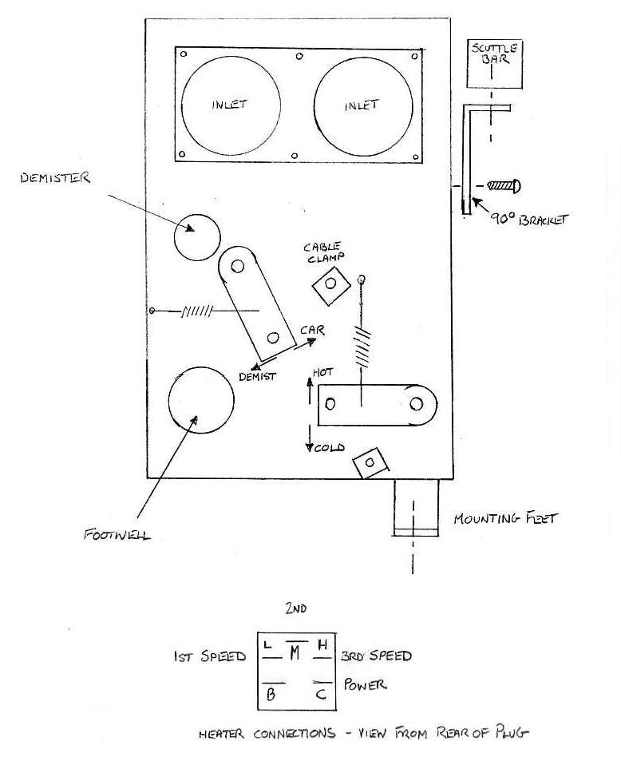
- Page 93 -
FITTING THE WIPER SYSTEM

Fit the wheel boxes into the three pre-cut holes in the scuttle panel after first cutting 5mm from the wheel box angled spacers, make sure that they are fitted with rack mountings at the lowest point – See Drawing No. TMX061. Then cut the joining tubes to length and double fare the ends – a pipe flaring tool will be required to complete this task; remember to leave the tubes approx. 6mm over the required length to allow for the flares. The last tube (furthest away from the motor) should be approx. 4” long and require only the one end to be flared.

Drawing No. TMX061

Wiper arm/ blade assembly
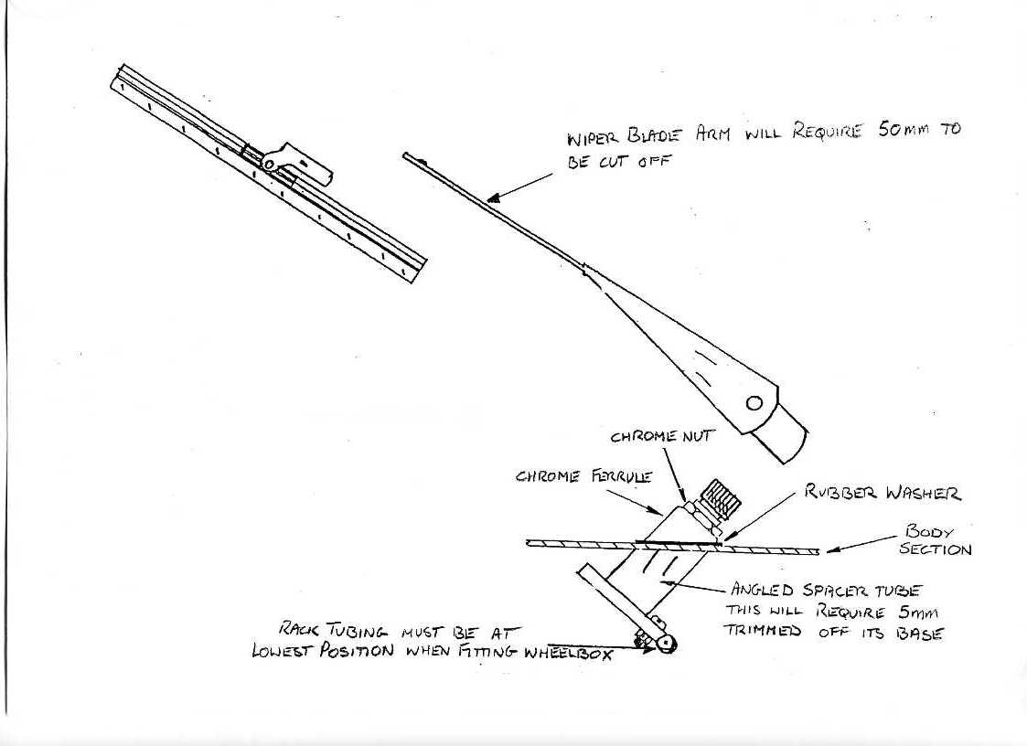
The wiper rack tubes can now be assembled, the last of which will determine the position of the wiper motor on the top column mounting bracket. The motor should be mounted as high as possible on the bracket to avoid fouling the dash end cap.

Assemble the drive gear into the motor along with the drive rack and replace the motor cover.
- Page 94 -
Now feed the drive rack through the tubes, engaging the wheelboxes as you go until the motor can be fastened to the tubes with the large securing nut.

The drive rack will hang out of the end of the last tube and should be cut-off with an angle grinder until level with the end of the last tube with the rack in its fullest extended position.

FITTING THE WASHER JETS

The washer jets can now be fitted – a small amount of material may need to be removed under the scuttle to allow the securing nuts to be fitted - and piped up; a ‘T’ piece and one-way valve (if not already fitted as part of the ‘T’ piece) will be required. The pipe can then be fed through the lower loom in the bulkhead and then attached to the washer bottle on the bulkhead or offside front inner wheelarch.

FITTING THE CARPETS

To fit the carpets you will need a good quality aerosol adhesive or brush-on carpet glue.

Start with the bulkhead carpet, this will need to be cut from the roll of carpet supplied - make sure that you trim right to the outside of the body. Cut a neat hole in the carpet over the insulated post on the bulkhead.

Next fit the tunnel carpet, cutting out the holes for the handbrake, gear lever and heater. Then fit the carpet to the rear bulkhead – NOTE if you are trimming the seatbelt post covers with fabric this will need to be done first.

The two sill carpets are next, they are glued over the sill and secured by the fibreglass sill covers, followed by the two floor carpets. Finally fit the boot carpet.

- Page 95 -
FITTING THE CENTRE CONSOLE

When the underlay and carpets have been fitted you can now fit the centre console.

Sit the console onto the tunnel, the front of the console should fit just behind the dash; now from underneath the car mark the position of the gearlever hole on the underside of the console, remove console from car and cut-out hole with holesaw. Sit the inlay panel into console and from underneath mark the position of the gearlever hole on the underside of the inlay panel, this can then be cut-out.

Replace the console into the car and centralise it over the gearlever hole, drill four holes through console and top of the tunnel. Countersink the holes in the console and screw down into the tunnel using countersunk self-tapping screws. The inlay panel can now be fitted – use four No. 4 countersunk self-tapping screws and surface cup washers, two at the rear of the console and two at the top below the dash to secure it in place. The gearlever, gaiter and stainless steel finisher can now be fitted; the finisher is screwed to the console, holding the gaiter in place. Any excess material from the gaiter can be trimmed off with a sharp Stanley knife, using the outside of the finisher plate as a guide.

Any holes for the electric window switches, radio controls etc will have to be cut prior to fitting and trimming the console.

On consoles where the vehicle is fitted with the Ford heater and Sebring conversion the centre console is supplied with the heater control mounting already bonded in place. On vehicles using the Sebring heater it is suggested that the heater controls (supplied fitted to a flat steel panel) are fitted to the inlay panel – see photographs at the rear of this manual for suggested layouts.

- Page 96 -
FITTING THE DASHBOARD, DASH ENDS & DASH TOP PANEL

Prior to fitting the instruments it is advisable to pre-fit the dashboard to the car first. Drop the steering column to its lowest position and fit the column; slacken the two bolts holding the column to the column mounting bracket – there should be sufficient movement to allow the column to be centralised in the dash cut-out.

Now offer the dashboard up behind the lip on the scuttle panel, and with the dash in its most central position drill through the scuttle lip at an angle – See Drawing No. TMX062. The dash is held by five No. 8 x 1” pan-head self-tapping screws, the heads of the screws will be covered by the dash top panel when it is fitted later.

Drawing No. TMX062
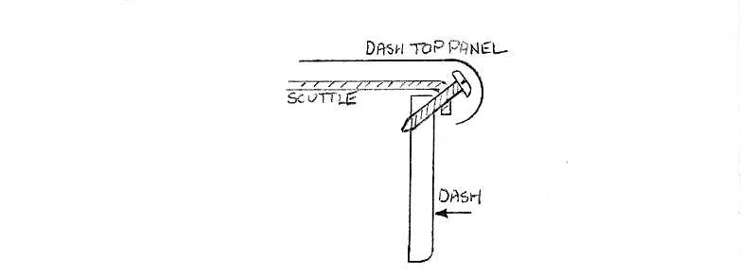

Now adjust the column until it is central in the column cut-out; lock the two column bracket bolts up, allowing the column to have full travel downwards on the adjuster and travel back towards the driver. The dash can now be removed.

The Sebring supplied dash instrument panel is shown in Drawing No. TMX063. Assemble the instruments, warning lamps and switches into the dashboard – do this on a soft cloth to avoid marking or damaging the dash material. The clamps for the instruments will require shortening by approx. 10mm, the warning lights and fog lamp switch will require a small blob of PU sealer to secure them in their positions.

- Page 97 -
The glove box moulding should be screwed to the back of the dash so that the right side of the moulding (as viewed from the front) is level with the right side of the aperture – this ensures that
the back of the moulding will not foul the demister tube and also allows the glove box lid catch to be fitted to the top right corner of the glove box. Viewed from the rear, some material will need to be removed from the moulding so that it does not touch the scuttle panel when the dash is fitted.

The instrument illumination (ancillary gauges only) should now be connected together; the three bulb holders from the ancillary gauges should be connected together with a connector supplied with the loom.

The dash can now be fitted to the car; wrap some soft cloth over the steering column and rest the dash there while you connect the wiring up. Finally screw the dash up to the scuttle as described above.

Drawing No. TMX063

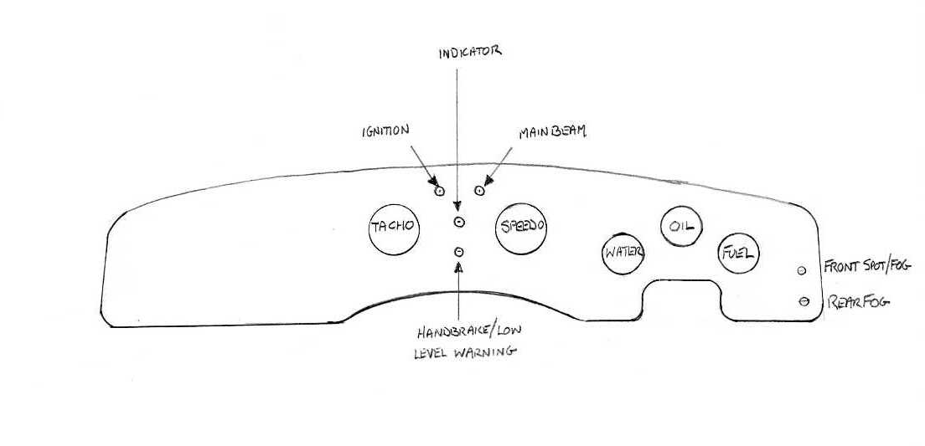
The moulded fibreglass dash end covers are screwed to the back of the dash panel level with the lower edge and sit behind the rubber door seal. Ensure you use the correct length of screws so as not to screw through the material covering the dash. Where the dash end sits behind the door seal a beading of PU sealer can be applied to help secure it.

- Page 98 -
Make sure there is sufficient clearance between the dash end and door hinge mounting bracket when the door is closed, if not, then the bottom of the dash ends will have to be sanded down to clear.

The dash top can now be fitted. It is held at either end by two countersunk screws and cup washers and in the middle by the interior mirror mounting bar.

FITTING THE FRONT & REAR LAMPS

The front headlamp mountings are fitted to the body with the self-tapping screws provided, they are positioned with the two adjuster screws – one at the top and the other at the 9 o’clock position as you look at the car. Thread the headlamp and front indicator wiring through the hole in the headlamp mounting and connect – refer to the wiring diagrams.

The headlamp unit can now be mounted, and after adjustment of the headlamps the chrome rim can be fitted – it clips onto the mounting and is secured by a screw at the bottom right-hand side.

The front indicators and rear stop/ tail lamps are fitted to the body with self-tapping screws. The rear lamps are fitted using the small clamps provided.

- Page 99 -
CONNECTING THE ELECTRICAL SYSTEM

Study the wiring diagrams on pages 38 to 44 – note: all multi-plug diagrams are viewed from the rear i.e. with the plug facing away from you.

The dash loom should be cable-tied to the scuttle bar, the rear loom should be routed up the back of the off-side door post and plugged into the dash and front looms. The dash loom should be plugged into the front and engine looms.

The wiper delay relay should be plugged into the terminal block on the nearside of the dash loom, it can be self-tapped or riveted to the scuttle bar. The wiper motor, heater and side repeater lamps can also be connected. Connect the brake light loom to the switch on pedal box.

The front and rear lamps and indicators can now be connected, but because of their location they are susceptible to road grime and vibration so it advisable that they are soldered.

The horns can be bolted to the two spare holes on the radiator side frames, an earth wire will have to be made up for each horn.

Remove any powder coating from all earth points to ensure a good earth connection and smear with a little grease to prevent corrosion.

The coil and radiator fan thermostat are fitted to the nearside inner wing and can now be connected;
the electric aerial should be connected next – if you are not using one then cable-tie the plug to the loom.

The steering column and ignition switches can be connected next; the interior lamps are fitted to the heater front cover panels and can now be connected.

The heater can now be connected – there are four wires to the fan switch and four wires to the heater unit; the black wire should be earthed on the scuttle bar, along with the side repeaters and other earths on the dash loom.

- Page 100 -
All the radio connections are listed in the wiring diagrams and their connections will depend on the unit to be fitted; wiring for a cigar lighter is provided in the loom, if not required tape up any ends and cable-tie out of the way.

The handbrake warning switch and brake fluid level low wiring can be connected; on the Ford brake reservoir cap with three terminals, use the outside two only.

The number plate lamp can be fitted along with the plate holder bracket which is held between the lamp and bodyshell using the lamp mounting bolts.

- Page 101 -
FITTING THE INTERIOR MIRROR

To fit the interior mirror you must first mark a central position on the windscreen frame – use the warning lights in the dash as your datum DO NOT use the middle wiper wheelbox as this is off-centre. Drill two holes in the windscreen frame, using the mounting as a template, being careful not to drill through and hit the glass.

The threaded bar is fitted through the dash top and scuttle panel and screwed into the bottom of the mirror mount, it should run parallel to the screen glass. Drill a 7mm hole through the dash top and scuttle in line with the dash warning lights, thread the bar into the mirror mount and fit the whole assembly to the car, adjust the bar until the washer fixed to the bar fits snugly on the dash top panel; screw the mount to the windscreen frame and fit the spacer and nut to the bottom of the threaded bar from under the dash.

The mirror and mirror arm can now be fitted by fixing it to the mount with the two screws provided – See Drawing No. TMX064.

- Page 102 -
Drawing No. TMX064
Interior mirror fitting
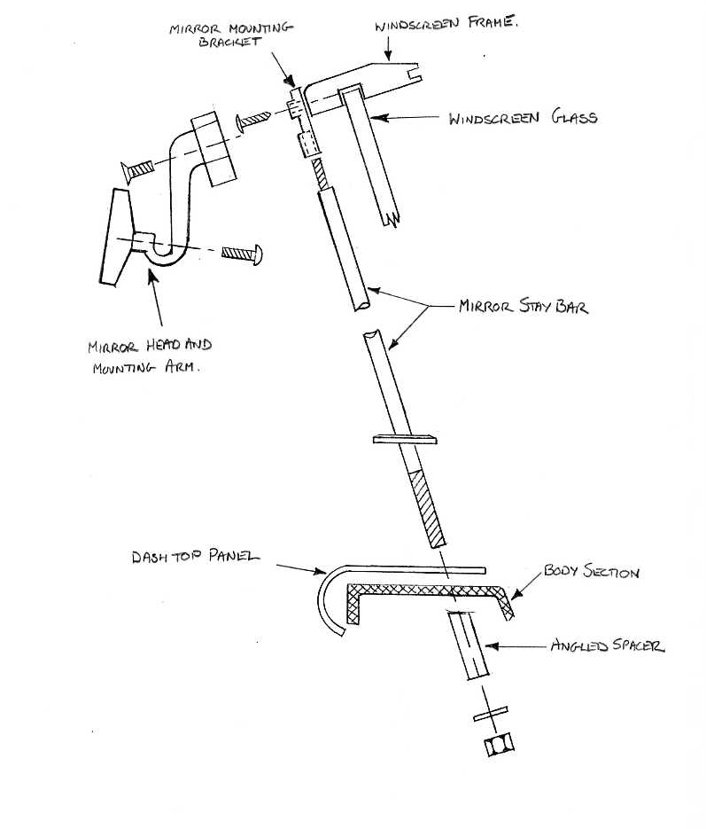

- Page 103 -
FITTING THE INTERIOR TRIM PANELS

Having already fitted the centre console the heater cover panels can now be fitted. Line up the edge of the panel with the lower edge of the console, the rear edge of the panel tucks inside the front edge of the console. Fix the panel with two countersunk self-tapping screws and cup washers at the rear and at the front by drilling through the panel into the side of the tunnel, use a long self-tapping screw at this point or you can tap out the hole to fit a long M5 screw. If you are using interior lights, these can be fixed to these panels.

The kick panels are fitted to the outside of the footwells, if you are fitting a radio then the speakers can be fitted towards the top of the panels. The panels should be self-tapped or drilled and tapped to the doorposts. At the front a small 90 degree bracket can be made from 3mm alloy plate and riveted to the bulkhead behind the kick panel, which can then be screwed to that bracket.

The three rear panels are fitted using the ‘Fir Tree’ type fixings; using masking tape on the fibreglass rear bulkhead, align the panels and press. The fir tree fixings will leave a small impression in the tape which can then be drilled (drill size is 7mm). Panels can then be knocked on using your hand.

The door panels can be fitted in the same way as above. The holes for the internal lock and window winder handle have been left for the bodybuilder to cut; carefully measure and mark the rear of the door and cut-out using a sharp Stanley knife – but only the rear panel and not the material until you are certain the hole(s) you have cut are correct.

Once the door panel is fitted, then the inner door handle can be fitted into place and the chrome door pull handle can be screwed to the door directly above the internal opening handle with two large self-tapping screws. Drill the holes approx. 40mm from the door top, the window winder handle (if fitted) can now be pressed on.

The handbrake gaiter can now be fitted; it is held down by the stainless steel finisher. Using the finisher as a template, drill into the top of the tunnel and use a self-tapping screw to fix the finished to the tunnel sandwiching the gaiter in between. Any excess material can be removed by cutting with a sharp Stanley knife.
- Page 104 -
FITTING THE SEATS

Fit the runners to the seats making sure that the adjuster is fixed to the seat and not to that part of the runner which is to be fixed to the floor.

Position the runners so that they are in line with the front of the seat; place the seat in the car – ensure that the seats are in a central position and as far back as possible. If fitting recliner seats, fit seats with the adjusters nearest the tunnel. Now mark the position of the holes in the runners onto the carpet with a wax pencil (or by placing masking tape onto the carpet under the runner and use a pencil).

Remove the seat and drill out the front runner holes (8.5mm) BEFORE YOU DRILL make sure that the holes do not foul the chassis outriggers underneath.

Replace the seat and bolt the runners down using the previously drilled holes; now using the seat adjuster slide the seat right forward to gain access to the rear runner holes – repeat the above procedure .

Once all four holes have been drilled, bolt the seats down – use spacers if required underneath the runners to give the desired seat height. Any excess bolt material may have to be removed to allow the fitting of the exhaust system.

- Page 105 -
FITTING THE SEATBELT POSTS AND COVERS

The fibreglass rear bulkhead has two areas scribed onto it, these need to be cut-out to allow the seatbelt posts to be bolted to the chassis. Cut out the marked area just inside the scribed lines, bring the seatbelt posts up from the wheelarch to inside the car – further trimming of the fibreglass may be required to allow fitment. Bolt the posts into position with bolts from the fastener pack.

The seatbelt post covers will require trimming at the bottom and sides to ensure a good fit – take a little off at a time. A square hole will need to be cut in the top of the cover to allow it to fit over the post tower – the marked square section on the cover is approximate only DO NOT cut-out without first checking that they are correct.

Once the covers are trimmed they should just cover the hole cut-out earlier, the top of the cover should be approx. 30mm below the body line on the rear bulkhead.

Cut strips of fibreglass matting approx. 25mm wide and bond the covers to the rear bulkhead along the bottom and sides – use a weight on the covers to hold them in place while the resin dries. The top of the covers and around the seatbelt post tower can be sealed with PU sealer.

FITTING THE SEATBELTS

The seatbelt inertia reel is fitted to the lower hole on the seat belt post – drill a 25mm hole through the fibreglass post cover, measure down 8.3/4” from the top of the post and pilot drill with a small drill bit (2mm or similar) on the central line of the post. If the drill bit is centre in the post threaded hole, the fibreglass can be drilled to 25mm.

Bolt the inertia reel to the post with 25mm spacer supplied – not forgetting to use a shake-proof washer under the bolt head, these are supplied with the seatbelts.

Next fix the anchorage to the top of the post using a bolt, shake-proof washer and reduced spacer – See Drawing No. TMX065.

- Page 106 -
Drawing No. TMX065
Seatbelt fittings
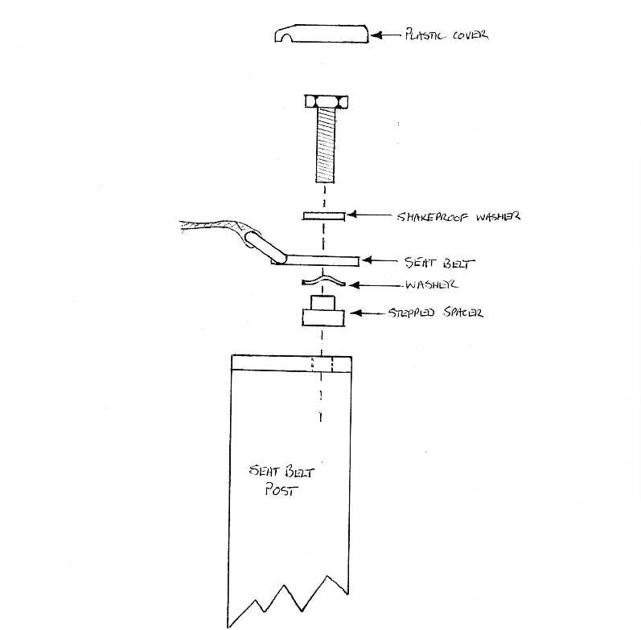

The lower anchorage can be fitted in much the same way as above; by first drilling through with a small drill bit - by looking from inside the rear wheelarch an approx. position for the anchorage can be determined. This anchorage will also require a 25mm spacer and a reduced spacer – the idea of these reduced spacers is to allow the belts to swivel at the anchorage points.

Finally the two storks can be mounted on the tunnel anchorage points, these are bolted directly to the tunnel.

- Page 107 -
FITTING THE FRONT & BONNET GRILLES

The front grille surround is held on by studs fixed to the rear of the grille casting, centrally at the top and bottom. Apply masking tape onto the body flanges at the point where the two studs will pass through. Offer the grille – making sure it is central in the hole and mark where studs will pass through the bodywork. Drill the holes 9mm diameter – this will allow for any adjustments – it is not unusual for the bottom hole to be on the very edge of the flange. A larger diameter washer will help spread the load when the nuts are tightened up.

Next, immediately behind the flange where the lower stud passes through, drill and file to shape a slot in the grille frame moulding – approx. 50 x 15mm – this will allow the lower stud nut to be tightened from underneath the car and will not be visible once the grille is tightened.

Before fitting, apply the foam strip to the rear face of the grille casting, following the line of the outside edge – this will help to prevent any damage that may be caused by the grille rubbing against the body.

The bonnet grille is simply bonded to the bonnet using PU sealer - place PU sealer on the three bonnet indents and a small amount on top between the indents and finally two blobs either side; press and hold the grille in position while an assistant tapes it in place with the masking tape.

Leave for a few hours then remove the tape and carefully remove any excess sealer.

- Page 108 -
FITTING THE SIDE VENTS

The Sebring side vent kit is supplied with 2ft of 1” wood baton, bonding past and catalyst. Cut the wood into 6” lengths, chamfer one edge of the wood to allow a good fit at the body/ side vent flange – See Drawing No. TMX066.

With some course sandpaper rough the area above and below the side vent hole; pour the catalyst into the tin of bonding paste and mix thoroughly. Once mixed, spread onto the two flats either side of the chamfered edge of the wood baton and position wood top and bottom of side vent hole – allow 24 hours to cure.

Position side vents into hole, making sure they are not touching any painted bodywork; when happy simply screw the vents to the wood baton using the screws provided. Some further trimming of the wood may be required to achieve a good fit – when correctly fitted the side vent fins should be approx. 8mm from the outside of the bodywork.

DRAWING No. TMX066
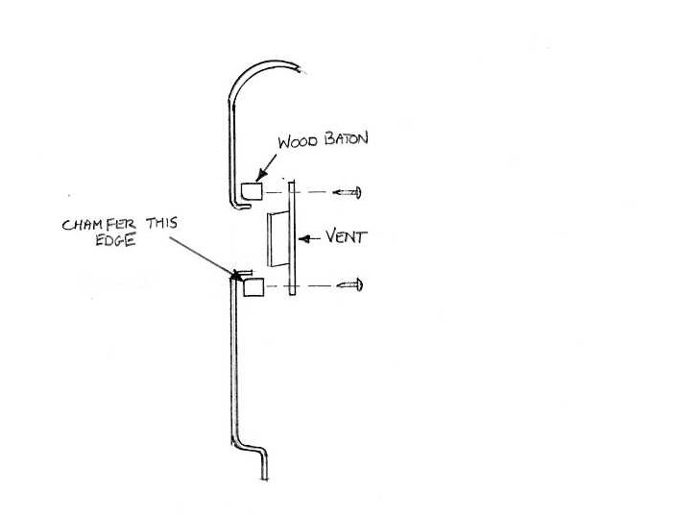

- Page 109 -
FITTING THE BONNET CATCH AND LOCK

To fit the bonnet lock, the radiator and frame must be installed first – DO NOT tighten the frame lower bolts. Fit the radiator cover plate to the radiator with two M6 bolts, allow the top panel to sit onto the frame top angle and mark the position of the four mounting holes in the panel onto the top frame angled bar with a centre punch. Drill these four holes out to 5mm and then tap M6.
With the top panel fitted, adjust the whole radiator frame assembly until the front edge of the top panel sits just behind the flange on the front body. Fully tighten the frame bolts.

With the panel still in position, mark the outside of the large hole in the panel onto the front body flange. These marks will be the position of the INSIDE of the two radiator frame to body braces that the bonnet lock is fixed to.

Remove the top panel - the two braces can now be fitted. Align the inside edge of the braces with the marks on the front body, now mark the inside edge of the braces onto the radiator top frame. It is best if these braces are welded to the radiator frame – they may need shortening to allow them to butt against the front edge of the radiator frame. Remove the top radiator frame and weld the braces to it, any local engineering workshop should be able to do this for you.

Refit top frame (now with braces attached), drill two holes through the front body flange and through the braces. Countersink holes in the body and fit screws and nuts provided in fastener pack.

Using the radiator top cover panel as a template, determine the position of the bonnet lock. It is fitted under the braces and held by four countersunk M5 screws and nuts. Drill the four mounting holes in the braces and countersink.

The lock should be fitted with the safety arm to the passenger side. When the top cover plate is fitted the lock should be central in the hole, with the front of the lock level with the cover plate and the rear slightly lower. This is to allow for the difference in angle of the radiator panel and bonnet lock mounting. Spacers may be required to achieve this. See Drawing No. TMX067.

- Page 110 -
Drawing No. TMX067

Radiator top panel/ front body braces & bonnet lock mounting
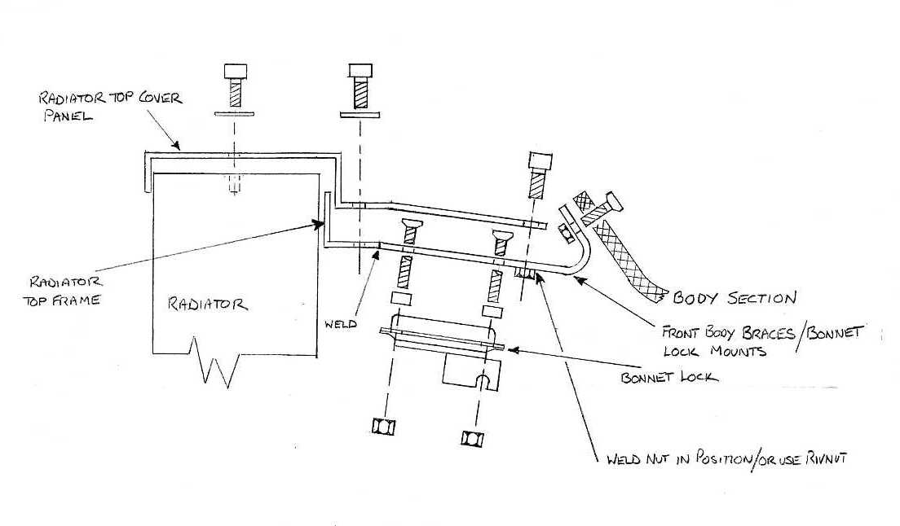Before the top panel is fitted the bonnet cable must be fixed. From inside the car, drill a hole through the bulkhead at the top on the outside of the Servo/ master cylinder. Route the cable through and along over the top of the front wheel arch to the lock – secure cable in place using a solderless nipple. Use the standard Ford column mounted handle and cable – the original Ford end will have to be cut off.

With the bonnet lock now fitted, press the catch into it in the fully locked down position. Apply masking tape to the bonnet liner where the catch will mount, lower the bonnet where the catch will leave an imprint in the tape of the spring adjuster screw on the catch. Lift the bonnet and drill out the hole to 13mm – this will allow for any small adjustments.

Release the catch from the lock and offer it to the bonnet, marking the two mountings and drilling through – these holes should be drilled to 10mm. There is a cutaway in the back edge of the bonnet liner to allow access so that the nuts/ washers can be fitted and tightened.
Carefully close the bonnet and check for bonnet to body height, this can be adjusted by the threaded screw in the catch; bonnet side gaps can be adjusted by moving catch on its mounting holes.
- Page 111 –
FITTING THE BONNET & BOOT STAYS

Two sliding latch style stays are provided (both of which are identical) along with four mounting brackets and rivets.

The boot stay mounting bracket is riveted to the boot floor through the boot carpet on the left-hand side, at the rear of the boot opening. Using the bolts supplied, bolt stay to mounting and also top mounting bracket to stay. Whilst holding the upper mounting bracket against the boot lid liner, close the boot lid as much as possible; position top mounting as needed, then carefully open the boot lid and mark the position of top mount. Drill and fit mount with one rivet only, re-check boot closure; if ok drill and fit second rivet.

The bonnet stay is fitted in the same manner as above. The bottom mount is riveted to the corner of the bulkhead just below the offside bonnet hinge.

FITTING THE STEERING WHEEL

Follow the instructions supplied with the wheel and boss for assembly by the manufacturer.

Depending on which manufacturer supplied the wheel and boss, the cut-out or pegs which operate the indicator self-cancelling bush should be at the nine o’clock position when viewed from the driver’s seat.

To fully centralize the steering wheel, this will have to be done whilst the front axle wheel tracking is carried out.

- Page 112 -
FITTING THE WIPER BLADES & ARMS

Before fitting the wiper arms and blades, switch on the ignition and operate the wiper switch – once the wheelboxes turn the wiper switch off, the wheelboxes will carry on moving and then stop; this will be the park position for the arms and blades. The park position must be to the offside of the vehicle.

The wiper arms are adjustable, however, to fit the Sebring screen they will require 50mm to be cut from the wiper blade mounting stalk. Fit the arms and blades one at a time, and operating the wiper switch, check and adjust until you are satisfied that the blade is giving as much coverage of the screen as possible without hitting the windscreen top frame. Lock the wiper arms by turning the small catch mounted underneath the arm at the midway point in-line with the arm.

FITTING THE BUMPERS & NUMBER PLATES – TMX ONLY

Both front and rear bumper blades are identical and are fixed in the same manner. Cut grommet in two and slide over bumper tube extensions against the bodywork. Before attempting to fit the bumper blades, wrap a good deal of masking tape around the ends to avoid scratching the paint finish should the bumper slip from your hands, I know it sounds unlikely but it does happen!

Drawing No. TMX068 shows the detail of the bumper fixings, the most important of which is the shaped spacer which is fitted between the bumper blade and the sprint, with the curve on the front of the spacer coinciding with the radius on the back of the bumper blade - ensuring the blade is not crushed as the bolts are tightened.

The two un-used holes in the front bumper are used to secure the front number plate and the two in the rear are blanked off with the two spare chrome dome bolts supplied with the bumper kit.

The rear number plate is attached to the holder under the number plate lamp with coloured plastic nuts and bolts. There are four plastic nut covers supplied with the bumper kit, these fit over M12 nuts holding the bumper mounting bracket and spacer tube.

- Page 113 -
Drawing No. TMX068
Bumper assembly
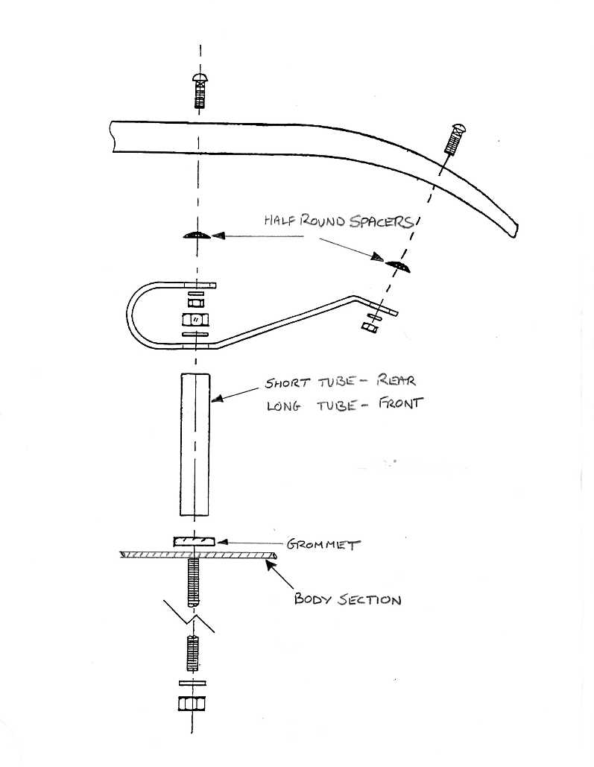

- Page 114 -
FITTING THE SUN VISORS

Assemble the hinges to the Perspex sun visor so that the fixing holes are to the outside edge, measure, mark and carefully drill the windscreen frame – the hole size is 2mm. Fit the sun visor assembly to the frame using the screws provided – See Drawing No. TMX069.

Drawing No. TMX069
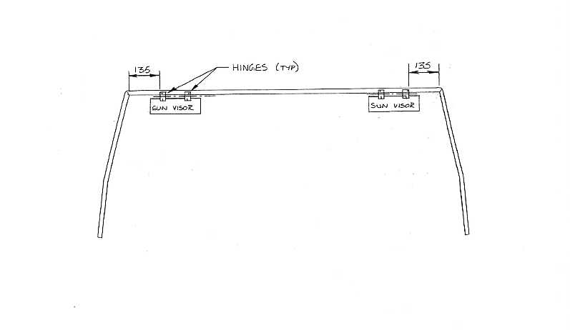

- Page 115 -
FITTING THE SOFT TOP & FRAME

Fitting the soft top is a straight forward affair and as long as the windscreen frame is in the correct place according to the datum measurements shown earlier, the hood will be a very secure fit with next to no wind noise of water ingress.

The dimensions for the hood bow retaining brackets are shown in the body pre-assembly drawings on Page 61.

Drill the front hole first and use the bracket as a drilling guide for the rear hole. Fit the main hood bow to the bracket with the smaller bow facing forward and the sliding adjusters approx. 5” up from the bottom of the main bow.

Lay the hood material over the bows and fix the Velcro securing flaps over the main bow, also slide the two webbing straps into position to retain the forward bow. Now push the hard strip machined into the leading edge of the hood into the groove that runs along the front face of the windscreen frame.

Stick a piece of masking tape to the rear scuttle just above the boot lid and mark the centre of the car onto the tape. Find the centre of the rear window and mark the centre of the roof onto the material with a piece of chalk.

Standing behind the car, grab the back edge of the roof material and pull it down as hard as you can and mark the position of the two press studs either side of the centre line. These two studs can now be fitted by drilling a hole and securing the fastener to the body with the self-tapping screws provided.

The next two studs to be fitted are just behind the doors to position the front corners correctly.
Fix the studs in the same manner and then adjust the front bow up or down, as necessary until the hood material is taut over both bows. Now slide the two aluminium stiffeners into the pockets sewn into the hood material just above the side windows.

- Page 116 -
The rest of the hood retaining studs are fitted by working the centre of the gap created by the two previous studs on each occasion. This spreads out the pulling force exerted and avoids ‘bunching’ of the material at any point. Work on alternate side of the care as you go to make sure everything stays evenly tensioned.

When all the clips are fitted, pull the loose ‘ear’ at the end of the screen around the front of the windscreen frame and mark a dot onto the screen frame through the centre of the ‘ear’. Drill a hole in the centre of this mark in the windscreen frame and screw in the retaining stud supplied with the hood.

Now enlarge the hole through the hood material a little and position the securing grommet over the hole, pushing the four retaining lugs through the material and fit the back plate over the four lugs.
Bend over the four lugs to secure the grommet to the hood material.

FITTING THE HOOD COVER BAG

The hood bag fits to the same retaining studs as the hood material, but the clips are supplied loose to allow them to be fitted in line with the retaining studs on the body. The hood bag is not clipped to all the retaining studs but to every alternate stud.

The hood material should be folded down and the hood bag laid on the top of the hood to mark the position of the clips. The clips are fitted to the cover bag by making a small hole with a sharp pointed bradawl or similar in the position required through the material and pushing the outer section of the clip through the hole.

The inner section of the clip is pushed onto the outer section, trapping the material in the middle, and the protruding section in the centre is burred over with a centre punch to secure the clip in position. Use a block of wood to rest the stud on whilst burring the back clip into place, this stops the black plastic coating on the outside of the clip from being damaged.

- Page 117 -
Two extra securing studs are needed to stop the hood cover bag from flapping when the car is moving, these are fitted to the inner trim panel just behind the seat and hold the inner return section of the cover in position.

Pull the cover bag down inside the car as far as it will go after all the clips are fitted and mark the position of the two extra clips onto the inner trim panel and the cover bag. Fit the clips in the same manner as before.

- Page 118 -
FITTING THE SPARE WHEEL

The spare wheel tyre size is 165/80/14 fitted to a standard Ford Granada 14” wheel. Slide the wheel into the spare wheel well with the dished centre of the wheel towards the front of the boot and one of the wheel stud holes uppermost.

With a scriber carefully mark the fibreglass through the stud hole, remove the spare wheel and drill a 13mm hole through the fibreglass on this mark. Temporarily screw the spare wheel holding bolt into mounting plate and hold the assembly against the fibreglass with the holding bolt through the hole. Now mark the four remaining holes and drill these out to 5mm, remove holding bolt from plate.

The mounting plate is riveted to the fibreglass boot wall with four large headed rivets, but must be held the other side of the boot wall. This will require someone to hold the plate from underneath the car whilst it is riveted from inside the boot.

Before fitting the spare wheel into its well, drill a 6mm hole at the lowest point in the spare wheel well to act as a water drain.

DRAWING No. TMX070
Spare wheel mounting
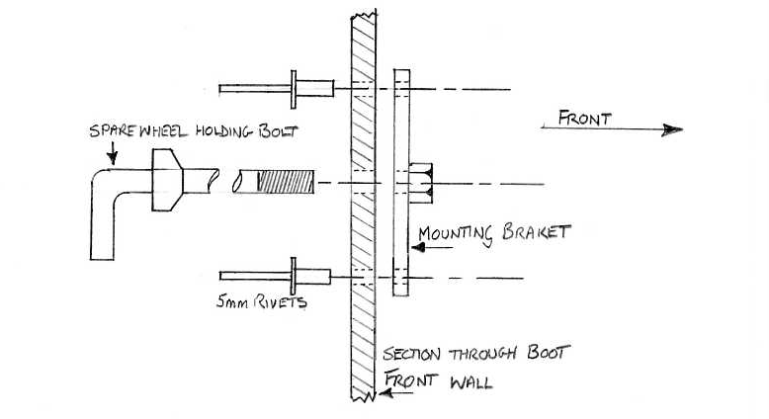
- Page 119 -

BLANK PAGES TO RECORD ANY ALTERATIONS YOU MAKE TO YOUR SEBRING TMX MXR

BLANK PAGES TO RECORD ANY ALTERATIONS YOU MAKE TO YOUR SEBRING TMX MXR

BLANK PAGES TO RECORD ANY ALTERATIONS YOU MAKE TO YOUR SEBRING TMX MXR

TEMPLATE
